COVID 19 GUIDELINES FOR VENUES OPERATING FOR THE PURPOSES OF LIVE ENTERTAINMENT AND NIGHTCLUBS

REVISIONS:

Version | Date | Description
 | 06/05/2021 | Initial publication
 | 24/05/2021 | Consultation feedback update
08 | 29/06/2021 | Secondary Consultation feedback update
09 | 02/09/2021 | ‘Reframing the challenge Continuing our Recovery and Reconnecting’
10 | 08/09/2021 | Consultation feedback update
11 | 19/10/2021 | Government Announcement
12 | 21/10/2021 | Further information following Government Announcement

REGULATIONS & RELEVANT GUIDELIINES:
The guidelines should be read in conjunction with the following documents:
- Code of Practice for Safety at Indoor Concerts, Department of the Environment, 1998
- Code of Practice for Safety at Outdoor Pop Concerts, Department of the Education, 1996
- Code of Practice for Safety at Sports Grounds, Department of Education, 1996
- Health and Safety at Work (Construction) Regulations 2013
- Fire Services Act 1981 and 2003
- Resilience and Recovery 2021 The Path Ahead
- Safety, Health and Welfare at work Act 2005
- Safety, Health and Welfare at work General Application Regulations 2007 – 2016
- Work Safely Protocol
- S.I. No. 218 of 2021 Health Act 1947 (Section 31A (6A)) (COVID-19) (No. 2) Regulations 2021
- S.I. No. 217 of 2021 Health Act 1947 (Section 31A - Temporary Restrictions) (COVID-19) (No. 2) Regulations 2021: REVISED to 13 October 2021
- S.I. No. 385 of 2021 Health Act 1947 (Sections 31AB and 31AD) (COVID-19) (Operation of Certain Indoor Premises)

TABLE OF CONTENTS
1 INTRODUCTION 5
2 COVID-19 PLANNING 10
3 KEY REFERENCE DOCUMENTS 14
4 GLOSSARY OF TERMS 15
APPENDIX A RISK ASSESSMENT STRATEGY 20
APPENDIX B SOCIAL DISTANCING 22
APPENDIX C MANAGEMENT STRUCTURE 25
APPENDIX D WORKER ARRANGEMENTS 32
APPENDIX E ARTIST AND PERFORMERS 37
APPENDIX F STAKEHOLDERS 40
APPENDIX G COMMUNICATIONS 41
APPENDIX H PATRON SCREENING 43
APPENDIX I HYGIENE, FACE COVERINGS AND RESPIRATORY ETIQUETTE 47
APPENDIX J CLEANING TO PREVENT CONTAMINATION 49
APPENDIX K HEATING, VENTILATION AND AIR CONDITION 53
APPENDIX L FOOD AND BEVERAGE 59
APPENDIX M ACCESSIBILITY 61
APPENDIX N OTHER SITE ACTIVITIES 62
APPENDIX O FIRST AID AND MEDICAL RESPONSE 63
APPENDIX P SUSPECTED CASE OF COVID-19 RESPONSE PLAN 66
APPENDIX Q MONITORING, REVIEW AND OVERSIGHT 70
APPENDIX R ALCOHOL BASED HANDS RUBS SAFE USE 71

DISCLAIMER:
All venues operating for the purposes of live entertainment and nightclubs are expected to have implemented the guidance outlined in the Work Safely Protocol for Employers and Workers at their Events.
The information contained within this document is based on the Government guidance available at the time of writing and will be subject to revision once the relevant regulations are finalised and following stakeholder engagement
More generally, this information is subject to change as new information on the COVID-19 virus emerges. Those using this guideline should verify the recommendations based on the most up-to-date information provided by the Government of Ireland, National Public Health and Emergency Team (NPHET) and the Health Service Executive (HSE).

INTRODUCTION

Objectives of the Guidance
In its Decision of 19 October 2021, Government agreed that the remaining aspects of the hospitality, entertainment and night-time economy sector can reopen only with the full range of protective measures in place and the wide and robust implementation of the COVID-19 pass. This represents an important next step towards the full reopening of our economy and our society, however, as we move forward it is more critical than ever that we ensure that we are doing everything we can to minimise opportunities for the transmission of the virus.
Measures outlined in the announcement are likely to last until at least next Spring. The use of COVID-19 passes remains an essential element of this reopening phase, particularly for indoor events and activities, and is underpinned by robust infection prevention and control measures.
The Government’s ‘Reframing the challenge Continuing our Recovery and Reconnecting’ published in August 2021 outlines the shift in public health management of COVID-19 in Ireland as it transitions from a focus on regulation and population wide restrictions to an emphasis on public health advice and personal judgement and personal protective behaviours. This movement away from regulations and population-level restrictions is only possible if individuals, organisations and communities ensure that we adhere to best practice in infection preventions and control, like observing good respiratory and hand hygiene, wearing a face covering in crowded and congregated settings and staying home and self-isolating when symptomatic.
The use of COVID-19 passes to access indoor events and activities is an essential element of the overall response to reducing transmission and protecting our communities. To maintain the current level of reopening activity, organisers and operators should ensure that they are checking all COVID-19 passes. Patrons and participants should ensure that they have their COVID-19 passes to gain entry to venues and settings. Compliance with this is a matter for all of us, and where a pass is not looked for, patrons and participants should ask why not.
Central to these guidelines is a commitment to adhering to best practice in infection prevention control measures which are necessary to protect individuals and society, as well as supporting our continued progress towards a full return to operation of our sector as the epidemiological situation allows. As it may not be possible to eliminate COVID-19 completely, it is essential that it is managed in a more ‘mainstream’ way where regular hand sanitising, good respiratory hygiene, wearing of face-masks, good ventilation become normalised rather than exceptional behaviour. Compliance with these measures should not be considered best practice but rather the minimum standard required to protect our communities.
This document intends to provide guidance for the reopening of venues operating for the purposes of live entertainment and nightclubs in a safe and controlled manner and to reduce the spread of the Coronavirus in these settings. This guidance builds on the previous Guidance for reopening venues and events, published by the Department of Tourism, Culture, Arts, Gaeltacht, Sport and Media in September. Not all of the guidance will be directly relevant to every venue but can be adapted and used to make venues operating for the purposes of Live Entertainment and Nightclubs as safe as possible.
The document outlines various policies and procedures which can be incorporated into all stages of the planning process of event and venue operations and procedures. The main objective is to create an environment where the risk of virus transmission is reduced to an acceptable or tolerable level while providing an enjoyable experience for patrons and managing the venue successfully. The policies and procedures outlined in this document should be integrated into event management processes of the venue.
The measures outlined in this document are intended to assist organisers by:
- Limiting the possibility of a COVID-19 outbreak due to event operations and venue management through Infection Prevention and Control measures;
- Ensuring business continuity through resource planning and avoiding loss of key personnel due to illness or being identified as close contacts while at work; and
- Safeguarding against reputational damage through implementation of these measures.

NOTE: Not all elements contained in this guidance document will be relevant for each venue or event, so it is important to tailor the information to individual needs.

Scope of the Guidance

These guidelines apply to venues operating for the purposes of live entertainment or nightclubs which meet the following essential conditions:
Nightclubs/Premises covered by these guidelines must meet the following conditions:
- Must be the holder of a current and valid 7 day licence or theatre licence.
- Must have been granted by the Court a special exemption order or occasional licence for each occasion they intend to operate beyond normal licensing hours.
- Must comply with the conditions of the special exemption order, occasional licence, dance licence and/or music and singing licences attaching to the premises.
- Must, on 22 October, have a designated performance area, stage or booth for performers and will typically also have a specialist sound and lighting system.
- Must, on 22 October, have a designated dance floor or standing or seating area which are specifically utilised only for the purposes of viewing a performance.
- Must generally cease operation at the end of the performance, having regard to normal licensing arrangements.
- Events should be ticketed as far as possible to facilitate contact tracing.
- For live performances, up to 1,500 patrons may stand with the remaining members of the audience sitting. Therefore, 100% seated capacity is permitted. For events with a combination of seated and standing capacity is subject to a maximum standing capacity of 1,500 and any additional capacity beyond 1,500 must be fully seated.
- For nightclubs no capacity limit applies.

Please Note: While night club or live entertainment venues can return to full capacity (subject to standing limits for live events), it is important that each venue operator determines what is a safe capacity for the individual characteristics of that venue and exercise judgement and caution with due regard to public safety. In this regard, individual venue operators should decide how best they can operate in the interest of protecting public health.
Guidelines are offered to assist with mitigation whilst COVID-19 is still circulating in our communities. Central to these guidelines is a commitment to adhering to best practice in infection prevention control measures which are necessary to protect individuals and society, as well as supporting our continued progress towards a full return to operation of our sector as the epidemiological situation allows.
The live entertainment and nightclub sector is diverse and is managed by a range of organisations. They range in scale and content and vary from one-off single events to more complex multifaceted programmes taking place in both permanent and temporary venues. This guidance is therefore scalable and can apply to a range of operational models. Nevertheless, as each event is different, it is for individual event organisers to work with their relevant stakeholders to determine how best to apply this guidance in particular circumstances. Not all elements contained in this guidance will be relevant for each event, so it is important to tailor the information to individual needs, having regard to the need to comply with any regulatory requirements e.g. checking COVID-19 passes.
For the purpose of these guidelines an event organiser in relation to an event in a place other than a dwelling is any person who;
- engages in the publicising, arranging, organising or managing of the event, or
- receives some or all of the proceeds (if any), from the event;”
This can include event promoters, venue management and event management teams. When applying these guidelines event organisers should consider the division of responsibilities with relevant stakeholders to ensure appropriate measures are in place. It is at the discretion of the event organiser and/or venue management to determine suitable arrangements to deliver COVID safe event(s).
These guidelines address events presented in indoor ‘Controlled Environments’. Venues operating for the purposes of live entertainment and nightclubs, following particular conditions can be considered Controlled Environments and offer the potential to manage interactions and therefore limit risks of transmission associated with COVID-19 and crowded environments. Controlled Environments are ones where the number of people and the ways that they interact can be actively managed. Businesses/services such as museums, cinemas, theatres and art galleries are deemed to be controlled environments when appropriate protective measures in place such as social distancing between people.
These guidelines are not aimed at mass participation events, trade fairs and conferences, weddings, parades and pageants, sporting fixtures and competitions, functions or events in private homes. However, content contained herein may be helpful in assisting in the delivery of events in these contexts. Organisers should consult guidance which has been developed specifically for these settings such as:
- Fáilte Ireland Business Conference and Business Event Venues
- Theatre Forum Reopening Forum
- Fáilte Ireland Hotels and Guesthouses

Key elements of the reopening plan
On this basis, from 22nd of October, it is proposed that:

- Venues operating for the purposes of live entertainment or nightclubs can reopen fully subject to the use of the COVID-19 pass and with a number of mitigation measures in place.
- Venues should meet the following conditions
  - Must be the holder of a current and valid 7 day licence or theatre licence.
  - Must have been granted by the Court a special exemption order or occasional licence for each occasion they intend to operate beyond normal licensing hours.
  - Must comply with the conditions of the special exemption order, occasional licence, dance licence and/or music and singing licences attaching to the premises.
  - Must, on 22 October, have a designated performance area, stage or booth for performers and will typically also have a specialist sound and lighting system.
  - Must, on 22 October, have a designated dance floor or standing or seating area which are specifically utilised only for the purposes of viewing a performance.
  - Must generally cease operation at the end of the performance, having regard to normal licensing arrangements.
  - Events should be ticketed as far as possible to facilitate contact tracing.

- Unaccompanied minors are also required to show a COVID-19 Pass.
- Facemasks should be worn in all indoor venues;
  - at all times by staff
  - at all times by patrons other than when they are dancing, drinking or eating.

Venues operating for the purposes of live entertainment and nightclubs should be aware that they may be subject to inspection by Compliance Officer from the Health Service Executive and/or the Health and Safety Authority to confirm compliance with appropriate COVID-19 regulations. All documentation and records should be made available to the compliance officer on request. Failure to do so could result in closure and/or prosecution under the Act.
Please Note: While night club or live entertainment venues can return to full capacity (subject to standing limits for live events), it is important that each venue operator determines what is a safe capacity for the individual characteristics of that venue and exercise judgement and caution with due regard to public safety. In this regard, individual venue operators should decide how best they can operate in the interest of protecting public health.

Event organisers and operators should refer to gov.ie for more details on the public health measures in place.

Other changes From 22nd October 2021
The following additional changes which impact on the operating environment of venues covered by these guidelines are also in place from 22 October:
- Specific distances for social distancing are being removed, however the sector should ensure that social distancing remains part of the overall infection prevention control measures especially for shared spaces e.g. restrooms, foyers, concourses etc. Although venues are permitted to operate to 100% they should have regard for adequate ventilation and other protection measures in deciding on an appropriate, safe capacity for operation.
- Operating times for licenced premises will return to normal.

Summary of Protective Measures

Permitted Capacity | Live entertainment - Up to 1,500 patrons standing, any capacity in excess of 1,500 to be seated with appropriate protective measures.  No restrictions on capacity for fully seated audiences.
Measures | - COVID-19 passes of patrons’ status to be checked, to provide proof of immunity status, ID should also be checked. These provisions are subject to the requirements of the Government regulations. A Record should be kept that the pass of patrons has been checked. (See Appendix H). Unaccompanied minors also need to present a COVID-19 pass.  - Social distancing maximised as far as is reasonably practicable especially in shared areas (See Appendix B).  - Maximised ventilation (See Appendix K).  - Ticketed events are encouraged to facilitate contact tracing (See Appendix H).  - Counter service permitted for food and beverage with effective queue system in place. Consumption of food and beverage not permitted at the counter (See Appendix L).  - Face Mask wearing required for workers at all times indoors (See Appendix D & I).  - Face Mask wearing required for patrons indoors, apart from when consuming food/drink and dancing (See Appendix I).  - Enhanced cleaning measures in place (See Appendix J).  - Contact tracing required for all individuals onsite. Can be obtained via through digital/mobile ticketing. For walk-ups contact details should be taken at the door i.e. party lead name and number (See Appendix H).  - Worker arrangements as per Work Safely Protocol (See Appendix D).  - Suspected case response plan in place (See Appendix P).  - COVID-19 Signage in place (See Appendix G).  - Hand sanitiser and hand wash facilities provided (See Appendix I).  - Resumption of normal licensing and operating hours.

 | Outdoors
Permitted Capacity | No capacity limits on outdoor events.
Measures | - Social distancing maximised as far as is reasonably practicable especially in shared areas. (See Appendix B)  - Proof of immunity for entry not required.  - Mask wearing required for workers where 2m distancing cannot be maintained. (See Appendix D & I)  - Masks encouraged but not mandatory for patrons in congested areas, while and when queueing. (See Appendix I)  - Enhanced cleaning measures in place. (See Appendix J)  - Worker arrangements as per Work Safely Protocol (See Appendix D)  - Suspected case response plan in place (See Appendix P)  - COVID-19 Signage in place (See Appendix G)  - Hand sanitiser and hand wash facilities provided (See Appendix I)  - Resumption of normal licensing and operating hours.

COVID-19 PLANNING

What is COVID-19
COVID-19 is an infectious disease caused by a Coronavirus. The virus is transmitted via the following methods:
Droplets or aerosols. When an infected person coughs, sneezes, or talks, droplets or tiny particles called aerosols carry the virus into the air from their nose or mouth. Anyone who is within 2m of that person can breathe it into their lungs.
Airborne transmission. Research shows that the virus can live in the air for up to 3 hours. It can get into lungs if an infected person has it breathes out and another person breathes that air in.
Surface/Fomite transmission. The virus can spread through surface transfer when an infected person contaminates a surface which is touched by another individual and transferred to the person’s nose, eyes or mouth when they touch them.
The virus most commonly spread through people who have symptoms. It is possible to pass it on without showing any signs, people who don't know they've been infected can give it to others (also known as asymptomatic spread). People can also spread the virus before you notice any signs of infection, this is otherwise known as pre- symptomatic spread.
The key principles in preventing the spread of COVID-19 include the following:
- Implementing enhanced cleaning measures;
- Maintaining a safe distance from other people;
- Implementing good hygiene and respiratory etiquette;
- Wearing a face covering/mask;
- Maximise Ventilation;
- Early intervention and isolation of suspected/ confirmed cases; and
- Contact tracing for workers and patrons.

COVID-19 Plan
A COVID-19 plan specific to the event/venue must be developed for each event/venue in line with current Government guidance. The COVID-19 plan details policies and procedures necessary for the organisers and managers in order to comply with Government and public health advice and to prevent the spread of COVID-19 in the workplace and at the event. Depending on the type of event and the venue the COVID-19 plan might be prepared by the event organiser, the venue management team or a combination of both. Again, the delineation and allocation of responsibilities will be dependent on individual circumstances of each event and venue.
NOTE: Not all elements contained in this guidance document will be relevant for each venue or event, so it is important to tailor the information to individual needs.
The COVID-19 plans should be treated as supplementary to existing operational plans and are not intended as a replacement for pre COVID-19 event management and/or safety and operational planning. The COVID-19 plan is intended to reassure all patrons and workers that it is safe to return to venues and events that comply with these guidelines. The plan further acts as an operational guide for venue management. The COVID-19 plan can be integrated into existing plans or be prepared as standalone documents to be read in conjunction with existing plans.
Developing a COVID-19 plan will help to clarify what is required to overcome the threat of COVID-19 and give workers and patrons confidence that they are in a safe environment.
Before developing the COVID-19 plan, organisers should familiarise themselves with the latest Government guidelines and public health advice. Information from these sources will assist in developing their COVID-19 plan. As part of the plan, organisers should:
- Appoint a COVID-19 Compliance Person/Team;
- Complete a COVID-19 Risk Assessment;
- Develop and implement Infection Prevention and Control Measures (IPCM) including; response plans for COVID-19 a suspected case and outbreak;
- Review standing capacity in line with appropriate restrictions and having regard to social distancing and virus transmission mitigating factors;
- Develop a Communication Plan; and
- Monitor & Review the COVID-19 plan.

As part of the COVID-19 plan organisations should also:
- Review and update the venue and event safety documentation as appropriate; and
- Review and update the Event Operational Procedures as appropriate.

Organisers should ensure those responsible for health and safety have the requisite knowledge and expertise in order to understand the risks associated with COVID-19. In the event that organisations and their workforce do not have access to these skills in-house, they should engage external support options as appropriate.
When preparing their COVID-19 Plan organisers should consider the concept of ‘Best Available Techniques Not Entailing Excessive Costs’ or ​BATNEEC for short. Control measures should not be cost prohibitive.
COVID-19 Compliance Team (CCT)
The organisers should appoint a COVID-19 Compliance Person/Team(s) for their event. There will be two distinct areas that the CCTs will need to consider: worker related issues and crowd related issues.
The COVID-19 Compliance Team shall be responsible for the planning, implementation and monitoring of the COVID-19 plan.
It is suggested that the CCT is made up of individual(s) who have status and influence to advise on the implementation of control measures and monitor compliance at the venue.
See Appendix C for further details on management structure.
COVID-19 Risk Assessment
The Risk Assessment is an essential part of the planning process and must be conducted as part of safety planning for all events. The risk assessments for each venue and/or event now needs to take account of risk of transmission of COVID-19 by identifying hazards which present a risk of a spread of infection between persons. A Risk Assessment can be integrated into existing systems or as individual documents.
See Appendix A for further information on Risk Assessments.
Infection Prevention and Control Measures (IPCM)
Based on the risk assessments, Infection Prevention and Control measures can be put in place that are considered reasonably practicable, to mitigate the risk of transmission of COVID-19 to a tolerable or acceptable level. The management and implementation of control measures will determine if the event can be considered a “Controlled Environment” as defined by the Resilience and Recovery 2021 The Path Ahead. IPCMs outlined in the Work Safely Protocol include:
- Social Distancing See Appendix B
- Worker Arrangements See Appendix D
- Stakeholders See Appendix F
- Hand Hygiene, Face Coverings and Respiratory Etiquette See Appendix I
- Cleaning to Prevent Contamination See Appendix J
- Dealing with a Suspected Case or Outbreak of COVID-19 in the Workplace See Appendix P

Information contained in this guidance document will also address measures and areas specific to live events including:
- Artist and Performer Arrangements See Appendix E
- Communications Plan See Appendix G
- Patron Screening See Appendix H
- Ventilation See Appendix K
- Food and Beverage See Appendix L
- Accessibility Considerations See Appendix M
- First Aid See Appendix O

NOTE: Not all elements contained in this guidance document will be relevant for each venue or event, so it is important to tailor the information to individual needs.
Develop Communications Plan
A robust communication plan is essential to achieving compliance from workers and patrons. The communications plan should inform workers and patrons of what is changing, what they need to do and how they are expected to behave.

All available means of communication should be used before, during and after the event, including ticketing platforms, social media, and websites, as well as signage in and around the venue, public address systems, and electronic displays.
Communications plan for the Venue and Organisers (and their team) should include clear expectations with regard to site inductions, briefings and general information to be provided to workers, contractors, patrons etc.
See Appendix G for further details on communications.

Record Keeping, Monitoring and Review
The COVID-19 plan should be reviewed regularly and updated as new regulations, guidelines and best practice become available.
Control measures implemented as part of the COVID-19 plan should be monitored on a continuing basis and corrective action taken as required.
See Appendix Q for further details on monitoring and review.
Review all Health and Safety Documents
Routine in-house health and safety procedures should be followed as instructed by the person responsible for health and safety for the event or at the venue. All health and safety documents should be updated to indicate changes resulting from COVID-19 prevention measures.
This will include a review of:
- Safety Statement and associated Risk Assessments
- Risk Assessments / Method Statements (RAMS) for all work on site. Particular emphasis will be required on “Close Working”, i.e. where persons cannot maintain social distance while working.
- Briefing Document such as Safe System of Work Plans / Site Induction briefings etc.
Review Operational Documents
Standard Operating Procedures (SOPs) and management documents should be reviewed and updated, where necessary, to include COVID-19 mitigating measures. The Event Management Plan (EMP) should be augmented to include the COVID-19 risk assessment, updates to the roles and responsibilities of personnel, and any relevant COVID-19 control measures to be put in place.
Some organisations may wish to embed the COVID-19 plan into current operational documents as opposed to being a standalone plan.

KEY REFERENCE DOCUMENTS
- CIF (Construction Industry Federation) Construction Sector C-19 Pandemic Standard Operating Procedures
- Code of Practice for Safety at Indoor Concerts, Department of the Environment, 1998
- Code of Practice for Safety at Outdoor Pop Concerts, Department of the Education, 1996
- Code of Practice for Safety at Sports Grounds, Department of Education, 1996
- Department of Enterprise, Trade and Employment: Work Safely Protocol.
- Department of the Taoiseach: Resilience and Recovery 2020-2021: Plan for Living with COVID-19
- European Centre for Disease Prevention and Control. Technical Report – Disinfection of environments in healthcare and non-healthcare settings potentially contaminated with SARS-COV-2
- European Centre for Disease Prevention and Control: Heating, ventilation and air-conditioning systems in the context of COVID-19
- Fáilte Ireland Guidelines to Re-Opening All Sectors
- Fáilte Ireland/Arts Council COVID-19 Guidelines for the Safe Presentation of Festival and Live Events
- Health Protection and Surveillance Centre Employer and Employee Guidance
- Latest Public Health Advice from the HSE
- National Standards Authority of Ireland: COVID-19 Workplace Protection and Improvement Guide
- Other published industry specific guidance documents including:
- S.I. No. 151/2000 Infectious Diseases (Amendment) Regulations 2000
- S.I. No. 326/2020 Health Act 1947(Section 31A – Temporary Restrictions)(COVID-19)(NO.4) Regulations 2020
- SG02 Guide to Safety at Sports Grounds: Planning for Social Distancing at Sports Grounds
- The Event Safety Alliance Reopening Guide
- Theatre Forum. Arts Centres - Working during COVID-19: A framework for Arts Centres and Performing Arts Venues
- World Health Organization. Getting your workplace ready for COVID-19
- World Health Organization. Key planning recommendations for Mass Gatherings in the context of COVID-19 – Interim Guidance 29 May 2020
- COVID-19 Risks and precautions for the performing arts. Vancouver, BC: National Collaborating Centre for Environmental Health. 2020 Sep. https://ncceh.ca/documents/covid-19-risks-and-precautions-performing-arts
- WHO, Cleaning and disinfection of environmental surfaces in the context of COVID-19
- S.I. No. 218 of 2021 Health Act 1947 (Section 31A (6A)) (COVID-19) (No. 2) Regulations 2021
- S.I. No. 217 of 2021 Health Act 1947 (Section 31A - Temporary Restrictions) (COVID-19) (No. 2) Regulations 2021: REVISED to 13 October 2021
- S.I. No. 385 of 2021 Health Act 1947 (Sections 31AB and 31AD) (COVID-19) (Operation of Certain Indoor Premises)

GLOSSARY OF TERMS
Aerosol Transmission | Person-to-person transmission of pathogens through the air by means of inhalation of infectious particles.
Rapid Antigen Diagnostic Tests  (RADTs) | A rapid antigen test, or rapid test, is a rapid diagnostic test suitable for point-of-care testing that directly detects the presence or absence of an antigen.
Build | Installing the facilities required to host an event.
Circulation | The free movement of people within a venue.
CIF | Construction Industry Federation
Cleaning | Physically removes dirt and germs/microorganisms from surfaces. It may not necessarily kill all germs/microorganisms but it will decrease the amount, thereby lowering the spread of infection. Cleaning is carried out with water, detergents, and using the physical action of rubbing or scrubbing.
Close Contact | Close contact can mean:  - spending more than 15 minutes of face-to-face contact within 2 metres of someone who has COVID-19, indoors or outdoors  - living in the same house or shared accommodation as someone who has COVID-19  - sitting within 2 seats of someone who has COVID-19 on public transport or an airplane  Spending more than 2 hours in an indoor space with someone who has COVID-19 will sometimes count as close or casual contact. This could be an office or a classroom. But it will depend on the size of the room and other factors. Public health doctors or contact tracers will let you know if you are at risk during contact tracing and public health risk assessments. https://www2.hse.ie/conditions/coronavirus/close-contact-and-casual-contact.html
Close Proximity Work | A number of persons engaged in a task which by its nature or location requires close proximity and could result in workers being deemed Close Contacts as defined by the HSE (see above).
Competent person | A person shall be regarded as competent in an identified role where he or she has sufficient training and experience to meet the national occupational standards relevant to the tasks within that role. Competency includes an awareness of the limits of one’s personal knowledge, skills or experience.
Concourse | A circulation area, covered or uncovered, that provides direct access to and from patron viewing areas, via stairways, ramps, vomitories, or level passageways, and serves as a milling area for patrons for the purposes of refreshment and entertainment, and/or provides access to toilet facilities, and which may also form part of the ingress and egress systems of the ground
Controlled Environment | An environment where the number of people and the ways that they interact can be actively managed. See Section 1.4 for further details.
Contact Tracing | Process of identifying persons who may have come into contact with an infected person (“contacts”) and the subsequent collection of further information about these contacts.
COVID-19 PCR test | A PCR test for COVID-19 is a test used to diagnosis people who are currently infected with SARS-CoV-2, which is the coronavirus that causes COVID-19.
COVID-19 Plan | The COVID-19 Plan details the policies and practices necessary for the employer to meet the Government’s guidance and to prevent the spread of COVID-19 in the workplace.
Disinfecting | Destroys most germs/microorganisms after cleaning and so lowers the spread of infection even further.
ECDC | European Centre for Disease Control.
Entry Point | Any controlled entrance, such as a turnstile, door or gate, through which patrons’ entre an event and are counted.
Event | A gathering of people, either static or ambulatory to view an activity organised for their benefit and enjoyment in a defined place which can be indoors or outdoors in a temporary or permanent facility or a combination of both. An Event also includes Trade fairs, conferences and business events.
Event Management Plan | An event management plan outlines all the safety and organisational aspects of an event.
Event Organiser (Organiser) | As part of the requirements of a controlled environment, Event management will have to nominate an event organiser as defined within Health (Preservation and Protection and other Emergency Measures in the Public Interest) Act 2020: “in relation to an event in a place other than a dwelling, any person who;  - engages in the publicising, arranging, organising or managing of the event, or  - receives some or all of the proceeds (if any), from the event;”  This can include event promoters, venue management and event management teams.
External Stakeholder | A party external to the management/ delivery of the event that has an interest in the event and can either affect or be affected by the event.
First Aid | First-aid means either:  - Treatment in a life-threatening situation (e.g. heart stoppage or severe bleeding) pending medical help, or  - Treatment for minor injury (e.g. cuts or bruises)
Flow Rate | The number of persons per minute passing through an element of an ingress, egress or circulation route.
Fomite | A fomite or fomes is any inanimate object that, when contaminated with or exposed to infectious agents, can transfer disease to a new host.
HSE | Health Service Executive
HSA | Health Safety Authority
IPCM’s | Infection Prevention Control Measures
Isolation | Separation of infected individuals and healthy individuals.
Lateral Gangway | Channel or the passage of patrons through patron viewing areas running parallel with terrace steps or seat rows.
Local Authority | An administrative body in local government that is officially responsible for all the public services and facilities in a particular area.
LWR | Lead Worker Representative. See Health and Safety Authority Role of Lead Worker Representative .
Management | Person or persons in overall control of the premise whilst people are present.
NPHET | National Public Health Emergency Team
NSAI | National Standards Authority of Ireland
Occupier | in relation to any premises or venue, means a person exercising such control over the state of the premises that it is reasonable to impose upon that person a duty towards an entrant in respect of a particular danger thereon and, where there is more than one occupier of the same premises, the extent of the duty of each occupier towards an entrant depends on the degree of control each of them has over the state of the premises and the particular danger thereon and whether, as respects each of them, the classification of entrant concerned.
Outdoor venue | An outdoor area is defined within the Public Health (Tobacco) Amendment) Act 2004 as:  - a place or premises, or a part of a place or premises, that is wholly uncovered by any roof, whether fixed or movable  - an outdoor part of a place or premises covered by a fixed or movable roof, provided that not more than 50 per cent of the perimeter of that part is surrounded by one or more walls or similar structures (inclusive of windows, doors, gates or other means of access to or egress from that part).
Patron | People other than your workforce that are onsite during an event which may include, but is not limited to, spectators (including ticket holders) and the general public and are required to follow health and safety procedures as a condition of entry and attendance.
Patron Viewing Area | Any area of a ground or structure in the venue provided for patrons, either seated or standing, to view the event.
Personal protective equipment (PPE) | All equipment (including clothing affording protection against the weather) which is intended to be worn or held by a person at work which protects them against one or more risks to their health and safety.
Social Distancing | Social distancing, means keeping a safe space between yourself and other people who are not from your household. To practice social stay an appropriate distance in line with current public health advice from other people who are not from your household in both indoor and outdoor spaces.
Promotor | See Event Organiser
Risk Assessment | Overall process of risk identification, risk analysis, and risk evaluation
Stakeholder | Persons, other than the defined workforce providing goods and services at the event these can include (but are not limited to): artists, participants, competitors, entertainers, vendors, exhibitors, 3rd party suppliers, etc.)
Visitor | An entrant who is present at the venue at the invitation, or with the permission, of the occupier or any other entrant.
Venue | Venue operating for the purposes of live entertainment or nightclubs. An event venue is any location used for an event. Venues range in size and location and available facilities. A venue can be indoor and outdoor (green space). It can be a permanent purpose-built venue or a temporarily purpose-built venue. A venue can be public or private property.
Vomitory | An access route built into the gradient of a stand or terrace which directly links Patron viewing areas to concourses, and/or routes for ingress, egress or emergency egress
WHO | World Health Organisation
Worker | Anyone working on an event or at an event venue, whether that be direct employees, freelance suppliers, artists, performers, suppliers, contractors, agency workers and specialist workers (such as riggers), seasonal workers, volunteers, artist liaison, runners, catering and cleaning staff and staff on zero hours contracts.
Workplace | Location(s) at which Event Organiser will plan, prepare and deliver events, recognising these could be different fixed or temporary locations at each stage of delivery and that these could be indoors or outdoors.
Zone Ex | The external zone (also known as ‘the last mile’) which lies immediately beyond the outer perimeter of the event site, consisting of a network of routes or areas, often leading to transport hubs, and whose management is considered key to the safe and secure arrival and departure of patrons.

APPENDIX A RISK ASSESSMENT STRATEGY
Risk Assessments are conducted as part of safety planning for all events. The risk assessments for each event and venue will now need to take account of the risk of transmission of COVID-19 by identifying hazards which present a risk of a spread of infection between persons. This includes workers, event patrons and members of the public and others proximate to the event. The COVID-19 risk assessment may be integrated into standard operating risk assessments or be produced as a standalone document.
The identification of hazards and implementation of control measures should be based on assessment against the principles of prevention (Elimination, Substitution, Engineering Controls, Administrative Controls & Personal Protective Equipment) and relevant guidance documents as applied to an environment having regard to the application of professional judgement and common sense to the particular circumstances.
Organisers should consider the transmission route when carrying out their risk assessment:
- Airborne
- Surface/ fomite transfer
- Personal physical contact (e.g. handshakes)

They should also consider the following factors when assessing COVID-19 transmission:
- The length of the event;
- The numbers involved in an event – workers and patrons;
- Whether direct contact is part of the event;
- Whether close proximity is part of the event;
- Contact group characteristics (e.g. single occupancy, pods);
- The environment in which the activity occurs (e.g. outdoors versus indoors);
- Demographic of patrons; and
- Type of event (theatre show, music concert, food festival etc.).

The key principles of prevention of spread of COVID-19 involve the following:
- Limiting potential contact with the virus so it cannot pass from one person to another;
- Containment of the Virus to reduce number of persons it can be transmitted to;
- Contact Tracing for early intervention; and
- Vaccination.

The assessment of the event should be a visual inspection of permanent facilities such as ventilation, any observations of physical limitations or temporary installations, cleaning methods, specific work practices, administrative processes and so forth.
Based on the risk assessment, control measures that are considered reasonably practicable should be put in place, to eliminate or mitigate against the risk of transmission of COVID-19. These should be in line with current public health advice.
It is not possible to completely eliminate the risk of transmission of COVID-19, the Appendices in this document set out reasonably practicable measures which can aid in reducing the risk of spread of COVID-19 in the workspace and at the event venue to a tolerable level in line with public health advice. Protective measures in isolation will not be sufficient to adequately reduce the risk, therefore organisers must apply a combination of control measures as appropriate.
Not all elements contained in this guidance document will be relevant for each event or venue, so it is important to tailor the information to individual needs.
The below table illustrates possible hazards for an event environment.
Management Issues | Physical Issues
- Lack of information for workers and patrons with respect to Public Health Advice  - Queuing and moving through circulation areas leading to lack of social distancing  - Sampling and activations providing loose paraphernalia handed out to patrons  - Duration of an event in relation to time in close proximity to large numbers of people  - Loud shouting and singing by patrons, which can increase the transfer of droplets  - Lack of social distancing outside the venue at entry and exit  - Multiple organisers utilising one venue concurrently | - Lack of adequate ventilation  - Insufficient hand washing facilities to maintain hygiene  - Toilets, sinks and urinals – shared touchpoints  - Contaminated shared touch points (handrails, lift buttons, etc.)  - Food and beverage concessions – shared touchpoints (cash, credit card machines, utensils and condiments) and social distancing (queuing)  - Intoxication (drugs and / or alcohol)  - Maintaining social distancing in circulation areas  - Searching patrons and/or their property  - Evicting patrons form the event  - Entrance and Exit lanes

APPENDIX B SOCIAL DISTANCING

B.1 Managing Social Distancing
Social distancing of people to prevent the transmission of COVID-19 is one of the key methods of preventing spread of infection. While a specific distance for social distancing has been removed for venues operating for the purposes of live entertainment and nightclubs, organisers should aim to maximise social distancing in the venue as far as possible. This should include maximising social distancing while queuing, using common areas like toilets and at the bar area, as well as in other transitory areas. The paragraphs below set out recommendations for control measures that can be applied to encourage social distancing by workers and patrons in a venue.

Additionally operators are advised that although 100% capacity is now permitted, each venue should consider whether the venue environment including ventilation is appropriate for 100% capacity and whether greater levels of social distancing should apply.

Please Note: While night club or live entertainment venues can return to full capacity (subject to standing limits for live events), it is important that each venue operator determines what is a safe capacity for the individual characteristics of that venue and exercise judgement and caution with due regard to public safety. In this regard, individual venue operators should decide how best they can operate in the interest of protecting public health.

B.2 Patron Ingress

Ticketing plan
The ticketing strategy for the event should consider the following:
- Digital/Mobile tickets should replace traditional paper tickets;
- Tickets should be secured in advance, where possible;
- Patron details (name and telephone number) should be requested as part of the sale of the ticket to facilitate contact tracing as required under SI 217 of 2021;
- Tickets for seated accommodation should be allocated to specific seats;
- Group bookings should be in line with current government guidelines applicable at the time of ticket issue;
- Ticket re-sale/exchange should be discouraged. Mechanisms for capturing changes in contact details should be established;
- Ticket holders shall carry valid ID to confirm identify if requested;
- Digital COVID Certificates or other relevant proofs of immunity provided for under SI 385 of 2021 should be requested on arrival

Patrons should be made aware that their contact details will be kept for a period of 28 days to facilitate contact tracing.
Digital/Mobile tickets should be scanned by ticket-takers or stewards while wearing face covering/masks and gloves or implementing enhanced hand hygiene.

Queue Management
Queue management will form an important element of the event plan. Queuing system can be managed by stewards, venue staff, or event workers. Ground markings and signage can also be put in place where possible to encourage social distancing while queuing although this may not always be possible with increased capacities. Facemasks should be worn in all queues, as these are mandatory apart from when dancing, drinking or eating in the venue.

Searches and checks
If searching is being implemented by licensed security providers at your event consideration should be made for the additional time required to carry this out. Consideration should also be made to the close contact element of this task. Security should avoid face to face and ensure they are wearing medical grade face coverings/masks. Any worker conducting a pat-down search MUST wear a medical grade face covering/mask and sanitise hands after each interaction.
Security providers should carry out risk assessments for all duties as part of their COVID-19 Plan.
Additionally, organisers should
- Communicate with the ticket holder in advance to inform them of;
  - Expected entry/search times, and to arrive early if necessary;
  - Rules of entry, including requirement for immunity, face covering/mask policy, and prohibited items;
  - Requirement of contact details for contact tracing
- Provide clear signage, public address announcements and/or stewards reminding people not to join the queue if they are experiencing symptoms of COVID-19 and to return home;

B.3 Circulation Areas and Facilities
Use
Circulation areas should be assessed and managed to maximise social distancing for patrons and workers. One way systems may be appropriate to minimise pinch points and overly congested areas. Facemasks should be worn by patrons at all times, apart from when dancing, drinking or eating.

Smoking areas
Smoking areas may require monitoring and management to prevent overcrowding.

Toilets – Temporary And Permanent
The following measures may be considered to allow for social distancing in toilet facilities:
- Queuing systems for entry. Where barriers are used to define queues, they should not impede emergency escape routes by creating trip hazards or blocking access to exits;
- One-way systems within the toilet facilities;
- Floor markings and signage indicating social distancing; and
- Use of disposable paper towels to speed up hand drying and reduce the risk of aerosol dispersal.

Temporary urinals and toilets should be positioned to aid in maximised social distancing. It is not advised to block alternative stalls, urinals and sinks as this may result in increased requirement for queuing footprint.
Facemasks should be worn by patrons at all times, apart from when dancing, drinking or eating.

B.5 Programming
Some events may be operating multiple stages or venues as part of their event. Organisers may wish to review programming to minimize congestion in communal areas and zones before, during intervals and at the end of the event. This may also be relevant for events held in shared venues or events held in urban areas next to other amenities.

B.6 Patron Egress
Flow rates through exits may be slower while trying to maintain social distancing. Exiting times may need to be extended to reduce pressure on the exits. Additional, control measures to ease pressure at egress may include:
- Staggered egress, allocating specific time slots for egress from each viewing area;
- ‘Row by row’ exiting, starting with the back row or row closest to the exit. The “church model” of leaving seats will prevent patrons queuing alongside other patrons seated beside aisles;
- Reconfiguring or providing temporary barriers to control flow and maintain channels separating lines of patrons egressing;
- Re-directing exit routes to different exits to distribute the exiting evenly around the event venue allowing for more rapid dispersal of persons from the vicinity of the venue;
- Provision of stewards to monitor, direct and advise patrons along the exit routes;
- Provision of additional exit routes, e.g. opening additional gates that are normally only used for workers or creating additional exits when designing the site;
- Increasing exit widths, where possible, to allow more patrons to pass through while socially distancing; and
- Consideration should be given to the potential movement of security and stewarding positions for egress and potential need for additional personnel.

APPENDIX C MANAGEMENT STRUCTURE

C.1 Managing Responsibilities
The safety of the public in places of assembly is the responsibility of those who organise the event and those who administer or own the premises or venue in which it is held. This arises from the Occupiers Liability Act and common duty of care owed by those in charge of the venue to the patrons attending the event and visitors to the venue. It is the joint responsibility of the venue management and the event organiser to ensure that standards and requirements for safety at the event are strictly observed before, during and after the event. The division of responsibilities between venue management and the event organiser should be clearly defined, agreed and recorded before the event.
Management of pre- and post-event activities is as important in the prevention of the spread of COVID-19 as at the event itself. It is the responsibility of the organiser to ensure that appropriate arrangements are made for all aspects of the event process.
It is acknowledged that the event management personnel in place and organisational structures may vary depending on individual circumstances and arrangements of the event or venue. The below designated roles and responsibilities are provided for illustrative purposes however event organisers may designate responsibilities in a variety of structures. Ultimately, there must be person(s) in charge at the event who can take responsibility for the safety of attendees and workers during the pre/post event build period and at the event.
Employers, workers and premises holders all have a duty of care to ensure “as far as reasonably practicable” the safety, health and welfare at work of workers and colleagues. The duty of care also extends to provide a reasonably safe environment for all users. COVID-19 policies and procedures should be integrated into worker/employer duties as appropriate.
If relevant Event Organiser/Venue Management Covid Compliance Teams must ensure that the event COVID-19 plan is assimilated with the venue COVID-19 plans.

C.1.1 Event Organiser /Promoter/Venue) Responsibilities
Organisers will have overall responsibility for reducing the risk of COVID-19 transmission at the event. They should provide the necessary supports to allow workers and stakeholders to perform their duties safely.
They should also:
- Appoint a COVID-19 Compliance Team;
- Ensure COVID-19 Risk Assessment is carried out by a competent person;
- Ensure COVID-19 Health and Safety Plan is prepared;
- Ensure adequate controls and procedures are in place at all times;
- Ensure the above are revised/updated when new information becomes available from Government and Public Health Authorities; and
- Ensure emergency response in line with Government and Public Health Authority for a Suspected COVID-19 case and outbreak is developed.

C.1.2 EVENT Controller
The Event Controller* has the status and authority to take full responsibility for all matters related to the management of an event. In addition to their usual responsibilities at an event as outlined in documents listed on page 2, the Event Controller should ensure that the content outlined in this document is implemented during the event. Including:
- Ensuring that adequate COVID-19 control measures are in place for the safety of workers and patrons;
- Ensuring that the COVID-19 plan is made available to all event personnel;
- Ensuring the COVID-19 Compliance Team is in place and aware of their duties; and
- Keep updated with Public Health Advice and updating the procedures accordingly.

C.1.3 Event Safety Officer
The Event Safety Officer* has the status and authority to take full responsibility for all matters related to the management of an event as they impinge on the safety, health and welfare of workers, patrons and the local community. In addition to their usual responsibilities at an event as outlined in documents listed on page 2, the Safety Officer may also:
- Ensure event operations are in compliance with Work Safely Protocol and the COVID-19: Reframing the Challenge, Continuing Our Recovery and Reconnecting;
- Ensure risk assessments are carried out by competent person(s);
- Ensure the control measures identified in the risk assessment have been implemented;
- Keep updated with ongoing Government and Public Health Authority and update the procedures accordingly;
- Ensuring that all event day workers are provided with and participate in necessary induction, training, and ad-hoc briefings;
- Ensure appropriate equipment and personal protective equipment is provided; and
- Ensure action checklists for the COVID-19 compliance officers are completed.

The Event Controller and Safety Officer may, where deemed appropriate, may delegate some responsibilities to other event personnel.

*For organisations that operate without an Event Controller or Safety Officer (smaller venues). A competent person must assume the responsibilities as outlined above.

C.1.4 COVID-19 Compliance Team
The organisers should appoint a COVID-19 Compliance Person/Team(s) (CCT) for their event. There will be two distinct areas that the CCTs will need to consider: worker related issues and patron related issues.
The COVID-19 compliance team shall be responsible for the planning, implementation and monitoring of the plan.
It is suggested that the CCT is made up of individuals who have status and influence to advise on the implementation of control measures and monitor compliance at the venue and event. The compliance team may consist of individuals from:
- The Event Control Team
- The Production Team
- The Site Management Team
- The Stewarding and Security Team
- Sponsorship and Marketing Team
- Volunteer Management
- Venue Management
- Catering and Concessions Team

The CCT should ensure that all aspects of event operations are considered including pre-production and planning, build period, show days and break period.
The CCT may include:
- Covid-19 Event Compliance Officer
- Covid-19 Deputy Event Compliance Officer
- Covid-19 Lead Worker Representative
- Covid-19 Stakeholder Representatives
- Covid-19 Administrative Coordinator

C.1.5 COVID-19 Event Compliance Officer
A COVID-19 Event Compliance Officer (ECO) should be appointed by the Event Organiser to coordinate and manage the event COVID-19 plan. The Covid-19 Event Compliance Officer’s responsibility is to ensure that Covid-19 Guidance is implemented as far as possible by their employers, and followed by workers, stakeholders, and patrons. Due to the challenges Covid-19 can present in the context of an event (inc. its build and strike) it is recommended that those fulfilling the role of a Covid-19 Event Compliance Officer have prior experience in the role of an Event Safety Officer.
The ECO should be suitably trained and experienced to carry out their duties. The ECO should report to the Event Controller, Safety Officer or other person in charge at the event.
Due to the size, nature, environment, and complexity of some events they may require more than one Compliance Officer and, where necessary, a supporting team. Organisers will also need to consider whether the role of the ECO can be integrated into current positions or if dedicated personnel is required.
The person(s) undertaking these roles must receive the necessary training and have a structured framework to follow within the organisation to be effective in preventing the spread of the virus.
It should be noted that the Event Controller and/or Safety officer for the event have overall responsibility for the design, implementation, and monitoring of all safety management systems and must also ensure compliance. They can delegate or assign responsibilities however must maintain oversight.

C.1.6 Covid-19 Deputy Event Compliance Officers
Due to the scale of some events, it is anticipated that larger events may require Covid-19 Deputy Event Compliance Officers. Their role should be similar to that of the Covid-19 Event Compliance Officer with responsibility for a specific area or department.

C.1.7 Lead Worker Representative
The Government’s COVID-19 Work Safely Protocol requires each workplace to appoint at least one Lead Worker Representative (LWR) to work with the employer to prevent the spread of COVID-19 in the workplace. A COVID-19 Lead Worker Representative should be appointed by the Event Organiser to represent workers in relation to COVID-19 and co-ordinate and oversee control measures as required.
The person(s) undertaking the role must receive the necessary training and have a structured framework to follow within the organisation to be effective in preventing the spread of the virus. Further information and a short online course on the role of LWR can be found on the HSA website. LWR HSA Training.
The number of LWR appointed should, ideally, be proportionate to the number of workers in the workplace and this person(s) should be clearly identifiable in the workplace.

C.1.8 COVID-19 Administrative Coordinator
For larger productions there will possibly be a need for an administrative coordinator to ensure that all paperwork has been submitted, collated, checked etc. This role can transition to an office based support role during the event for the Compliance Team.

C.1.9 Covid-19 Stakeholder Representative
As events require multiple suppliers, contractors, service providers, entertainers etc. it adds another level of complexity with regard to managing Covid-19 before, during, and after the event.
Where a Lead Worker Representative’s role is orientated towards workers the role of the Stakeholder Representatives ensures that all stakeholders are engaged with in the same manner.
Working together employers, Covid-19 team members, and Stakeholder Representatives can ensure measures are in place and adhered to, to help keep everyone safe and prevent the spread of Covid-19.
While measures can be put in place by an employer, organiser and / or their team a plan can easily fail if all of the relevant stakeholders are not informed properly and communicated with. Unlike most businesses, events have a number of “external” stakeholders operating at one time.
In the context of managing Covid-19, stakeholders include all parties working at the event along with those visiting the workplace in a work capacity. Below is a sample list of potential event stakeholders:

- Artists
- Catering Staff / Vendors
- Cleaners
- Contractors
- Entertainers
- Local Crew
- Security Contractors
- Service Providers
- Suppliers
- Visitors

Each stakeholder working onsite should name a Lead Worker Representative or COVID-19 compliance officer(s) for their team to liaise with the Stakeholder Representative/ Event COVID-19 Compliance Officer. Sole traders shall take up the role of compliance officer for themselves.

C.1.10 All Workers
All workers associated with an event share in the responsibility for the safety and wellbeing of workers, patrons and the greater community. All workers must:
- Must wear face masks where required;
- Follow the public health advice and guidance;
- Work with the Organisers and their employer and follow any specific procedures and instructions;
- Adopt good hygiene practices, such as frequent hand washing, respiratory etiquette and social distancing;
- Get professional healthcare advice if they are unwell;
- Not go to work if they have any symptoms of COVID-19; and
- Let their employer know if they believe there are reasons why it is not safe for them to be at work.

Employee/worker checklist are available from the HSA HERE.

C.1.11 Security and Stewards
Event Organisers may wish to engage stewards and security to take on COVID-19 compliance duties for patron areas. They may advise and assist patrons in implementing control measures and should be able to address any public concerns with respect to COVID-19.

C.2 Handover Mechanisms
Mechanisms and processes will need to be established for confirmation that control measures are implemented appropriately at the event. Mechanisms may take the form of checklists, visual inspections, verbal confirmation etc.

C.3 Sample Org Charts
Sample organisational charts below illustrate the possible organisation structure for management of COVID-19 at an event. Please note that organisational and management structure will vary depending on the size of the event or venue and resources available. It is acknowledged that the below examples may not be appropriate for all organisations or events.

Example 1: Sample COVID-19 Compliance Team – Large Scale Event

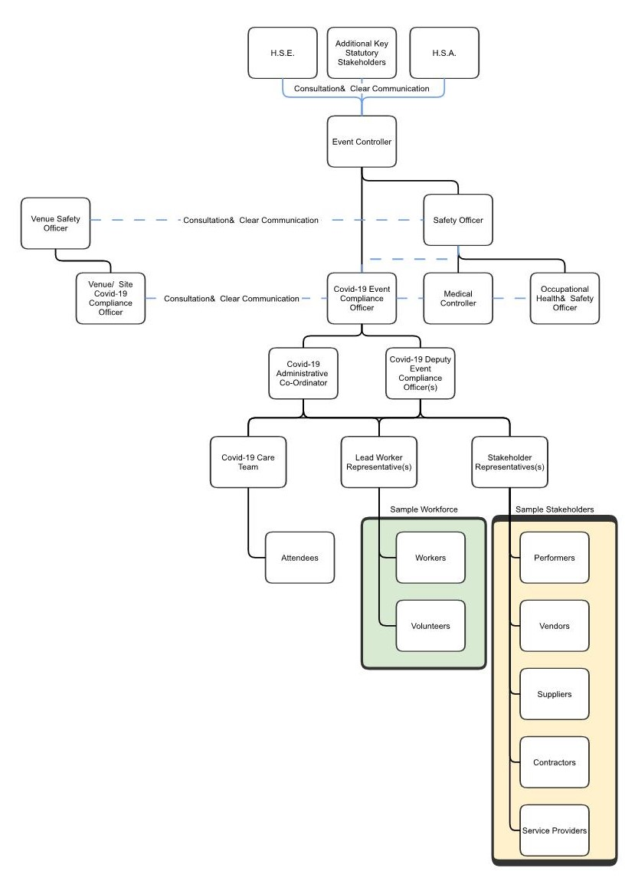

Example 1: Sample COVID-19 Compliance Team – Medium Scale Event
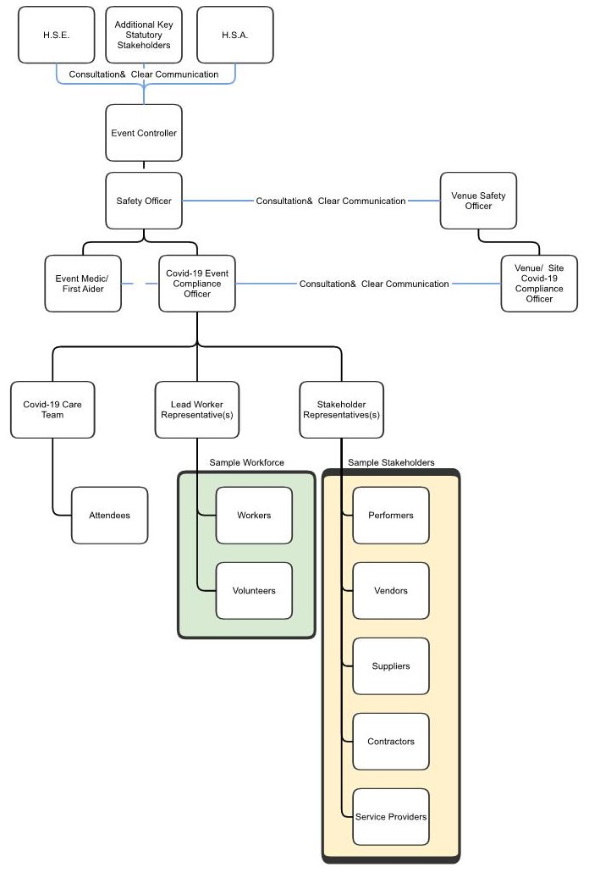

APPENDIX D WORKER ARRANGEMENTS
Under the Safety Health and Welfare at Work Act 2005 (Part 2, section 8) employers are required to:
- Provide and maintain a safe workplace, machinery and equipment;
- Manage work to ensure the safety, health and welfare of workers;
- Assess risks and put a safety statement in place;
- Provide and maintain facilities for your workers, such as clean toilets and washing facilities;
- Provide appropriate training and information.

This includes protecting against any risk associated with COVID-19 in the workplace. Therefore it is important for organisers to ensure they follow the Work Safely Protocol (WSP) developed under the aegis of the Safety Health and Welfare Act 2005. This document is due to be updated and published at the end of September 2021.
All workers and employers providing products and services onsite should ensure they are in compliance with the WSP. They should also implement and adhere to the following policies and procedures.

Health Declarations
In advance of commencing or returning to work event workers are required to complete a ‘Return to Work Declaration’ -to confirm to the best of their knowledge that they:
- Do not have symptoms of COVID-19;
- Are not self-isolating or restricting your movements;
- Are not waiting on results of a COVID-19 test;
- Have not recently returned from travel abroad.

Workers should complete and return the form no more than 3 days before they intend to commence work.
All declarations are private and should be treated with the utmost confidentiality. Records must be kept in line with data protection regulations. Further information is accessible on the Data Protection Commission website available HERE.
It is not necessary for workers to submit a health declaration each time they attend work or the event venue. However, there will be an ongoing requirement for workers to immediately report any symptoms or possible exposure to COVID-19 to the Compliance officer, CTT or other designated individual. COVID-19 symptoms are outlined by HSE HERE.

Induction Training
On returning to, or starting work at an event/venue, every worker must undergo an induction training programme. The training should include current advice and guidance on public health, it should also cover any changes to work practices. The HSA have published HSA Online Training for workers for COVID-19. They have also issued a Workers Checklist to inform workers of their individual responsibilities in helping to stop the spread of the virus. This sheet can be given to workers as part of their induction training. A full list of resources can be found HERE.
It is suggested that inductions are pre-recorded and made available in advance to avoid the need for in-person on site inductions.
Any event specific guidance and procedures which relate to the workplace, or the event should also be relayed to the workers prior to them commencing work.
Further briefings may be required throughout the day to update the workers of any changes.
Adequate time should be allocated for worker briefings prior to an event. These may extend the working day significantly and should be taken into consideration when assigning shifts and changeover, if necessary.

Contact Tracing
Minimum contact details (Name, number) should be collected and retained as required for all workers. The Event organisers should request agreement to the use of this data from workers at time of collection, as required by Government directives. These details should be gathered by the event organisers and/or venue management depending on the individual circumstances.
Minimum contact details are also required for all artist, performers and entourage, including any guests in attendance that have been granted access to the event such as those with event accreditation.
The Data Protection Commission has provided advice on processing data for contact tracing. Contact logs should be held for 28 days, after which time they can be discarded. See HERE for further information.

Accreditation
All persons operating in the venue on an event day should be accredited or be approved for access prior to entry. Only persons who have completed their training and provided a health declaration should be approved to access the event venue.
Contact details of all accredited individuals, including a contact telephone number, must be retained for a period of 28 days by Event Organisers to enable contact tracing.
Consideration to be given to venues that have multiple organisations on site concurrently.

Reducing Non-Essential On-Site Personnel
The number of personnel at the venue during an event should be limited to essential workers only. Essential workers are the people required to deliver an event. Stewarding and security numbers should be limited to the smallest number that can safely perform their duties at the venue. However, it is acknowledged that additional staffing may be required to manage social distancing and queuing in circulation areas.

Close Proximity Work
Close proximity work should only be carried out when absolutely necessary. When work requires close proximity the method statement and risk assessment should be updated to address the risk of transmission of COVID-19. Close proximity work could result in a close contact therefore these workers must keep a contact log for contract tracing purposes.
Workers should wear a face mask at all times when social distance cannot be maintained including while lifting equipment with another worker.
The following should be taken into consideration when carrying out close contact work:
- Ensure the worker does not have symptoms of COVID-19;
- Face mask and personal protective equipment is worn in line with the risk assessment and method statement;
- Contact log is kept for workers;
- Workers should wash and sanitise hands regularly;
- At the end of the task all tools and equipment must be sanitized properly.

The definition of a Close Contact is available on the HSE website.

Shift and Pod Work
The organiser may develop plans to change shift patterns to protect the workforce, optimise the operation of an event and act as close contact mitigation. This may include contingency measures to address:
- Increased rates of absenteeism;
- Implementation of the measures necessary to reduce the spread of COVID-19;
- Changing work patterns;
- Loss of key personnel at a critical time due to COVID-19 related illness;
- Deputy staff positions for key roles in the case of absenteeism due to COVID-19.

Pod work or work partnerships may also be considered to limit contacts throughout the day. Restricting close contacts to a limited number of persons in a Pod will help contain any possible infection and allows for quicker contact tracing and testing. Consequently, persons can only belong to one pod and cannot move between pods. Pods should be divided into dedicated work zones: whether that be artist liaison, front of house, on stage, accreditation, ticketing concessionaires, vendors and suppliers etc. so that departments don’t mix. Identify any roles that typically operate in multiple areas and minimise these where possible and implement additional protective measures.
For example, a dedicated group of four, working in the back of a truck in a theatre, to get the scenic elements brought to them to load, and tie off. Or pairing up site crew on an outdoor build, so the same pairings are used for the whole build/break period whenever there is close proximity work to be carried out.
Changing pods should be avoided. If pods changes are necessary, an appropriate period of time should be allowed between stopping works with one pod and commencing works with another. Additionally, employers/ organisers may wish to implement rapid testing when changing pod structures.

Personal Protective Equipment (PPE)
The Event Organiser should ensure the provision and maintenance of PPE to ensure safety at work where it is not reasonably practicable to control or eliminate hazards. The level of PPE required for various tasks should be considered in the risk assessment. Mandatory training in the safe use and disposal of PPE should be provided. PPE recommended to reduce virus transmission include gloves and surgical face masks with appropriate CE markings. It should be noted that gloves should not replace the need for regular handwashing.
Gloves, surgical face mask and eye protection should be used when cleaning and caring for someone who is suspected to have COVID-19.
Appropriate PPE such as surgical facemask, gloves, long sleeved gown and eye protection should be provided as standard for first aid kits. If aerosol generating procedures are being performed a surgical facemask is not sufficient therefore a properly fitted respirator mask (FFP2 or higher specification) is required.
Consideration should be given to keeping a supply of surgical face masks at entrance points to make available to individuals who may have forgotten to bring their own.
The HSE offer advice on How to wear a face covering. You can find guidance on When to wear gloves on the Centre for Disease Control and Prevention website.
Most construction and technical crew will not require PPE beyond what they would normally use for routine tasks.
Note: not all face coverings can be classified as personal protective equipment as they may not comply with basic health and safety requirements. Face coverings are deemed to be in conformity with the regulations if they bear the CE mark.

Work Areas and Activities
As far as reasonably possible, a distance in line with current public health advice should be maintained between workers. This is currently 2 metres, where 2 metres is not possible, other measures to protect workers should be in place. As well as face covering/mask, physical barriers such as sneeze guards/plexiglass and partitions can be useful, particularly in areas where it is difficult for individuals to remain apart. These physical barriers need to be regularly cleaned and disinfected. Screens may be fixed or mobile depending on requirements including emergency access. Adequate ventilation will be important in these circumstances, see Appendix K for further information on ventilation.
Worker areas should be separated from the patrons, and from the different worker pods, as far as practicable.
Scheduling staggered shifts will reduce the demand on facilities at start and end of shift and at breaks.
Changing Rooms, drying rooms, break rooms/canteen and locker rooms should be laid out to optimise social distancing and provided with appropriate ventilation.

Shared Vehicles
Use of multi-occupancy or shared vehicles should be avoided as far is possible. Where multi-occupancy or shared vehicles are used, workers should consider:
- Maintaining social distancing through suitable seating arrangements;
- Keeping the journey as short as possible;
- Wearing face covering/masks while in the vehicle;
- Only travelling with members of their own pods;
- Keeping vehicle windows open at all times or as much as possible weather and environmental conditions permitting (dust);
- Practicing good hygiene before and after using the vehicle. Organisers should provide hand sanitiser where necessary; and
- Vehicle heating and ventilation systems should not be set to recirculate air.

Where it's not possible for worker to social distance in a vehicle, consider additional measures such as:
- Using physical screening, so long as this does not compromise safety, for example by reducing visibility;
- Sitting side-by-side not face-to-face; and
- Using a fixed pairing system if people need to work in close proximity.
Event Organisers must ensure vehicles are cleaned regularly, particularly between different users. Commonly touched areas in vehicles include:
- Handles (inside and out);
- Steering wheel and starter button;
- Centre touchscreen and stereo;
- Handbrake and gearstick;
- Keys and key fob;
- Indicators and wiper stalks; and
- Windows, mirrors and mirror switches, seat adjusters and any other controls.

Where private chauffeur services are engaged, organisers should ensure appropriate COVID-19 plans are in place by the company.

Communications and monitoring
Communications with workers must be ongoing to ensure continued compliance with control measures. Ongoing monitoring and verbal reminders from COVID-19 compliance team members regarding social distancing etc. are essential.
Contractors and suppliers must ensure they continually monitor compliance for their own workers at the event.

Returning to Work After COVID-19
The HSA has introduced interim guidance to assist employers and workers manage a return to work following COVID-19 testing or infection. The Fitness for Work interim guidance and related checklists are available HERE.

APPENDIX E ARTIST AND PERFORMERS

Risk Assessment and COVID-19 Plans
Activities that involve rehearsing or performing can result in close interactions and infection spread in rehearsal areas, onstage, backstage and during breaks before, during and after activities. Risks of transmission are increased during various activities such as
- Vocalisation
- Playing musical instruments
- Dancing/ performing

Artists and their teams have a responsibility to follow all necessary guidelines and procedures that have been put in place at the event to protect against the spread of COVID-19. Organisers should discuss this with performers in advance to ensure they are not encouraging attendees to breach event protocols and/or increase the risk of the spread of the virus through their actions (i.e. load chanting/singing, social distancing).
Organisers should request that artists and performers prepare a COVID-19 risk assessment and plan for their performance. Alternatively, organisers may include the performance in the event COVID-19 plan and risk assessment. Artist and performers should nominate a representative to liaise with the organiser’s compliance team and ensure compliance performance and event IPCMs.
Organisers should also ensure that artists, performers and entertainers are aware the events IPCMs and of their role in providing a COVID-safe event by complying with social distancing and hygiene protocols. This includes safeguarding the welfare of their colleagues and patrons of the event at which they are working.
In the instances of producing models, where the organiser is the employer of the artists and performers, organisers should ensure the performance and associated activities are included in the COVID-19 risk assessment and plans.
The Theatre Forum Creating Work Guidelines is a useful resource for performers and producers when preparing and planning works.

Infection Prevention and Control Measures
When determining the appropriate control measures for artists and performers, consideration should be given to social distancing of performers with additional protection measures where required, such as physical screens, or, facing brass and woodwinds away from crowds and other performers. Organisers should also consider:
- Distancing for audiences and performers depending on activities;
- Reducing the duration of the shows;
- Reducing numbers of performers on stage;
- Increase ventilation in performance areas and during change over periods;
- Increase cleaning and disinfection to reduce fomite transmission;
- Performer testing and screening regimes;
- Consideration of performers effect on the crowd behaviour;
- Updating ‘Show Stop’ procedures for significant crowd noncompliance.

Event Organisers and venue managers should agree with co-producers, artists and workers all working procedures, responsibilities and protocols throughout rehearsals, build, technical installations, show days to load out.
Artists and performers should practice social distancing as far as practicable while on the stage and throughout the performances unless they are working in a pod. The stage and ancillary areas should be cleaned before and after use and hand sanitizers available to use when they go on and off the stage.
Performers should not be permitted to partake in high-risk activities such as crowd surfing, moving through the crowd or throwing personal items into the crowd.

Close Contact Activities
As part of live performances close contact activities and shared equipment can be unavoidable such as costume fitting, hair and makeup, working with sound and amplification equipment. COVID-19 risk assessments and plans should be carried out and prepared for all activities to ensure compliance with current Government guidance.
Some performers may be operating in a close contact pod which may permit them to work in close contact without face covering/masks. In certain circumstances it may be appropriate to consider the implementation of a testing regime to reduce the risk of infection spread amongst key workers.

Performance Location
The location and orientation of the performance area will determine the appropriate infection prevention and control measures required to reduce the risk of transmission between performers, other workers and patrons. Stage areas have many touch points including ramps, load in areas, designated workspaces etc.
Performances on the ground (circus or street performance style for example) will require appropriate barrier systems and/or management to ensure social distancing between performers and patrons can be maintained.

Performer and Artist Areas
Organisers shall be responsible for ensuring that event facilities for performers and artists such as green rooms, dressing rooms and rehearsal spaces are included in the event plan and that they are managed and operated in compliance with Government guidance and public health advice.
Where there are multiple performers or artists using the facilities (green rooms, staging etc.) thorough cleaning and disinfecting should be carried out before and after each use to avoid potential cross contamination. Room capacities should be clearly signposted on entry. Organisers should consider all people to these areas (guests, artist liaisons, stage managers etc.).

Artist Travel and Quarantine test
Workers including artists, performers and touring crew/workers must adhere to the Government Restrictions with respect to international travel. It should be noted that local national guidance will supersede guidance of country of origin, or native country.
Organisers should carefully monitor the official advice and information from the Irish Government and the Department of Foreign Affairs.

Show Production equipment and cargo
Commercial hauliers for international cargo and freight must follow Government advice and restrictions with respect to deliveries and transport. There may be delays at ports as a result of COVID-19. Additional measures may be required for equipment imported from overseas such as disinfection and/or quarantine of equipment which cannot be effectively sanitised.
Production equipment and cargo should be sanitized when loaded and unloaded at the event venue. Any equipment that cannot be adequately disinfected (e.g. speakers, softly furnished items) may be quarantined in an allocated area. This can be inclusive of transit time if minimally touched during transit. Once the event has concluded, workers can clean and disinfect equipment, in preparation for freight.
In addition to face covering/masks, workers should ensure they wash and sanitise their hand regularly after handling equipment and cargo to prevent contamination.

APPENDIX F STAKEHOLDERS
Stakeholders providing goods and services at the event including but not limited to artists, participants, competitors, entertainers, vendors, exhibitors, 3rd party suppliers, etc. should follow measures outlined in Appendix D for their workers.
All employers including organisers, venue management, contractors, suppliers, concessionaires etc. have a responsibility to provide a high level of service while ensuring the safety of their workers, patrons, and the wider community. Event Organisers should ensure that all stakeholders have developed a COVID-19 plan in line with the government’s Work Safely Protocol.
Stakeholders should ensure sufficient staffing contingencies in the event of a worker experiencing symptoms of COVID-19 and being unable carry out their duties.
All stakeholders with workers on site should provide details of their COVID-19 Compliance Officer and Lead Worker Representative to the organisers.
Stakeholders visiting or working onsite must follow the events IPCMs and take into account public health advice in preventing the spread of COVID-19.
All stakeholders who come on site and work at the event must sign a health declaration prior to entering. Organisers should provide event specific COVID-19 induction outlining the organisers COVID-19 plan key information including details of the compliance officers and suspected case response plan.

Documentation
Standard health and safety management procedures for suppliers and contractors should also be implemented. Organisers should request contractor and supplier health and safety documents ensuring they take account of the risk of transmission of COVID-19.

Site Management COVID-19 Compliance Team
Site management’s responsibility includes assessing various work scenarios to ensure that the key requirements such as social distancing, hygiene and face coverings/mask controls are being implemented. This involves briefings with site workers and constant reminders of COVID-19 IPCMs on site during the build and break. Site management should carry out regular site walks and inspections to ensure all site workers, contractors and suppliers are wearing appropriate PPE, practicing social distancing and implementing good hand hygiene and respiratory etiquette. All health declarations and confirmation of induction training should be collected by site management COVID-19 Compliance Officer(s). Individuals should not be permitted to commence work until they have completed the health declaration and COVID-19 training.
The Construction Federation of Ireland offers good guidance on COVID-19 mitigation for construction sites and construction workers. C-19 Standard Operating Procedures can be found HERE.
All aspects of the build/ break period must be considered when implementing IPCMs including:
- Deliveries and collections;
- Production scheduling;
- Worker management;
- International crews and touring teams;
- Close contact working;
- PPE requirements;
- Shared vehicles.

Shared equipment management, heavy equipment such as forklifts, boom lifts, and scissor lifts should minimize the number of operators of each piece of equipment where feasible.

APPENDIX G COMMUNICATIONS
Clear and concise communication with workers and patrons is an essential part of managing risk at the event. A comprehensive and reliable communication plan can be provided to inform all persons attending the event as to what measures have been put in place for their safety, and to inform patrons of what is expected of them. A strong communication plan will also allow persons attending the event to have up-to-date information and be aware of changes as they occur.
Management of attendee expectations will be an important part of the communications and crowd management plan. Patrons must be made aware of changes to the normal event experience such as social distancing, possible delays, longer wait times and face covering/mask requirements.
Event rules and terms and conditions should be updated to include COVID-19 and any requirements for entry (immunity status). IPCMs and arrangements should be in place if the event is cancelled or postponed as a result of new restrictions.
All efforts must be made to remind patrons not to attend the event if unwell, awaiting COVID-19 test results or under direction to remain in isolation/quarantine.
Before an event takes place, management should inform the patrons, using all available communication channels, of both:
- The safety measures that have been implemented in the venue, and
- Their responsibilities when attending the event.

This will reassure patrons of the safety precautions in place for their own safety. It will further assist in the operations on the event day as patrons will know what to expect and will be able to plan accordingly.
Communications with patrons should give clear and concise information informing them, where applicable, of:
- Requirement to show a valid COVID-19 Pass;
- Conditions of entry – e.g. requirement to show a valid COVID-19 pass;
- Their responsibilities in terms of hygiene and respiratory etiquette, social distancing and wearing of face covering/masks;
- Their responsibility to remain at home if they are experiencing symptoms before the event or are a close contact of a suspected case;
- Their responsibility to personally assess themselves for fitness to attend, e.g. if they might be considered vulnerable people;
- Advice on what to do if they develop symptoms while at the event;
- Advice for travelling on public transport including the possibility of limited services;
- Suggested arrival times to account for possible increased queuing and to inform of staggered entry times, if imposed;
- Location of entry points and exit routes related to their allocated area;
- Any difference in standard entry procedures or checks they may need to undergo;
- Payment methods at concessions (e.g. if contactless payments, or click and collect methods are being used);
- Changes to the usual available refreshments, e.g. if there is a no-alcohol policy; and
- Ticket return policy communicated to patrons who are unable to attend because of illness/close contact.

Communications methods
Event Organisers should communicate to patrons through all available means including:
- Website for the venue, event, or artist;
- Social media channels for the venue, event or artist;
- Ticket purchasing sites;
- Emails and push notifications;
- Mobile apps;
- Signage leading to and at the event venue; and
- Event workers and stewards communicating verbally.

Patrons should be advised via all available communication methods to stay at home if they are experiencing symptoms of COVID-19. It is up to the individual to carry out a personal risk assessment to determine if they should attend, in particular this relates to those with pre-existing health conditions that may be considered “vulnerable people” in relation to COVID-19 public health advice.
All patrons should be encouraged to download the HSE COVID Tracker App

Signage
Appropriate COVID-19 information signage should be installed in key locations (entrances, concourse/circulation spaces, toilets, food and beverage areas) to remind patrons of their responsibilities and provide way finding information. The signage should be placed in prominent positions and be clear and legible.
Signage should be regularly reviewed to ensure it is displaying the latest Government guidelines or Event specific protocols.
Signage may take the form of the following:
- Vertical signage prominently mounted in key locations indicating social distancing, face covering/mask protocols and other relevant information, advice and guidance;
- Floor markings indicating social distancing;
- Electronic displays and screens within circulation areas can also show relevant information; and
- Big screens can also be used to give instruction to patrons. This may be particularly useful if there are specific exiting procedures that they need to follow.

All messaging should be clear, concise, and consistent. Messaging should adhere to the guidelines for signage, visual contrast, and audibility for people with disabilities as outlined in Technical Guidance Document Part M and BS8300: 2009.

Suspected Case and Outbreak Communications
It is advised that a media strategy be developed in the unlikely event of a positive case or outbreak following an event. This may take the form of a holding statement with a few key points and information. This will assist in protecting the reputation of both venue and organisers and provide reassure to patrons.

APPENDIX H PATRON SCREENING
To minimise the likelihood of COVID-19 entering an event through infected patrons and the risk of transmission to workers and other patrons it is recommended that patrons complete some form of health declaration and/or screening before attending any event. The health declaration and screening process adopted by organisers will vary depending on type of event (indoor vs outdoors). Minimum suggested methods include:
- Terms and conditions of sale at the time of ticket purchase require the purchaser to
  - Acknowledge that they take responsibility for monitoring their health and the health of those attending in their group; and/or
- Produce a DCC or other relevant COVID-19 pass with photo ID at event/venue
- Where appropriate, request confirmation a specified time out from the event that ticketholders are symptoms free, are not awaiting the results of a COVID-19 test, are not self-isolating or restricting their movements and have not travelled outside of Ireland in the last 14 days;
- Signage at the venue reminding patrons that they must not attend if they are experiencing symptoms of COVID-19;
- Where appropriate, Event App with specific questions to be completed in advance of attendance. All patrons should also be encouraged to download the HSE COVID Tracker App.

Proof of Immunity and Photo ID
For entry into venues operating for the purposes of live entertainment or nightclubs, COVID-19 passes must demonstrate that the patron has either:
- Been vaccinated against COVID-19;
- Recovered from COVID-19 in the last 6 months
Patrons should also be asked for photo ID to prove that the COVID-19 pass relates to them.
The most common proof of immunity is likely to the Digital COVID Certificate (DCC), although other proofs are acceptable including a HSE vaccination card or international equivalent. Relevant proofs are set out in SI 385 of 2021.

The DCC is free and contains necessary key information including:
- The name of the individual;
- Their date of birth;
- The date of issue;
- Relevant information about your vaccine or test or recovery;
- A unique identifier number.

Accompanied minors (children under 18 years old) are not required to be fully vaccinated or recovered to attend events and do not need to show a COVID-19 pass
Unaccompanied minors (children under 18 years old) are required to be fully vaccinated or recovered to attend events and must show a COVID-19 pass
All venues operating for the purposes of live entertainment and nightclubs need to check DCC certs with accompanying photo ID to allow patrons to gain entry.
For operators covered by these guidance, information on how to check COVID-19 passes for indoor hospitality) is available on the Fáilte Ireland guidelines HERE.
Under S.I. No. 385 of 2021 Health Act 1947 (Sections 31AB and 31AD) (COVID-19) (Operation of Certain Indoor Premises), as amended, venues operating for the purposes of live entertainment or nightclubs are required to retain a record that proofs of immunity were checked. This is separate to the contact tracing requirements. No personal information should be collected or retained.

Contact Tracing
Organisers shall have in place a system to collect the contact details of patrons to assist in contact tracing systems – this should involve the collection of names and telephone numbers of lead members of a party. See link HERE for more information on contact tracing.
It is recommended that all venues for the purposes of live entertainment and nightclubs consider holding ticketed events only which could incorporate contact details of patrons for the purposes of contract tracing.
The Data Protection Commission has provided advice on processing data for contact tracing. Logs should be held for 28 days, after which time they can be securely disposed of. Further information is accessible on the Data Protection Commission website available HERE.

The following pages show examples of COVID-19 passes for jurisdictions outside of the EU.
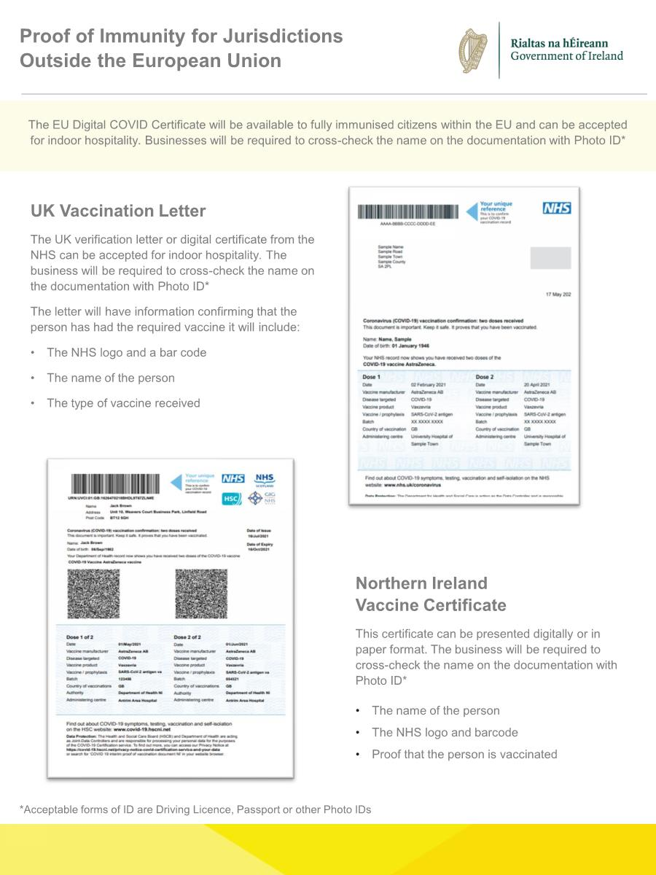
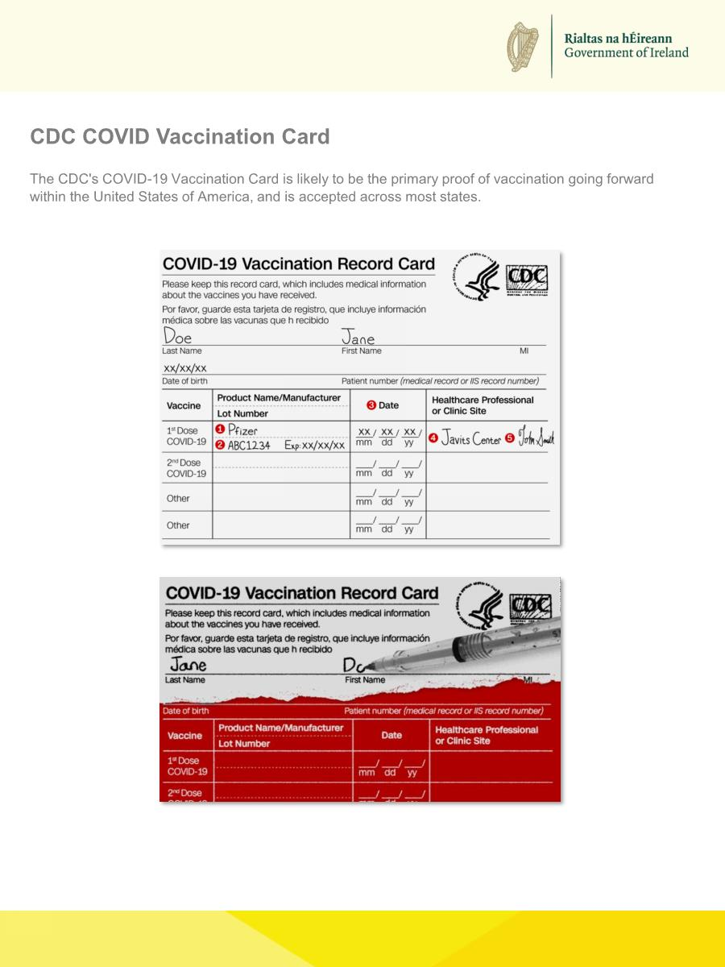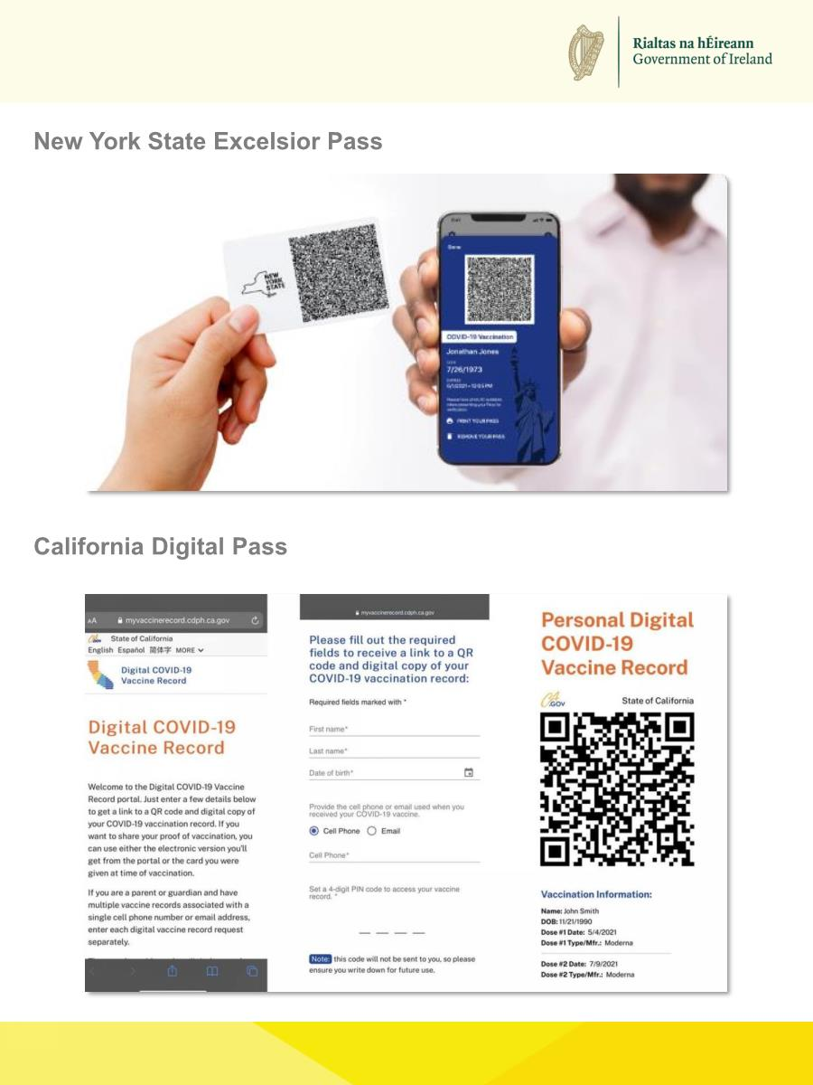

APPENDIX I HYGIENE, FACE COVERINGS AND RESPIRATORY ETIQUETTE

H.1 Hand Hygiene
Good hand hygiene will aid in preventing the spread of COVID-19. It is important to encourage frequent hand washing using soap and warm water and that all workers and patrons are familiar with and follow HSE Hand Washing guidelines. Between hand washing, the use of hand sanitisers (alcohol (minimum 60%) or non-alcohol based) is recommended. In choosing a hand sanitiser, it is important to ensure that it is effective against COVID-19.
Hand washing facilities should be made available to all workers and patrons. Hand sanitising units should be placed in key locations at entrances, food and beverage areas and throughout the venue and circulation areas for patrons’ and workers use.
Event Organisers and venue managers should monitor hand washing/sanitising areas to ensure sufficient supplies are available at all times.
Hot hand washing facilities are advised for events where workers have the potential to have heavily soiled hands (site work etc.)

Toilets
In addition to social distancing measures outlined in Appendix B, the following measures should be considered:
- Appropriate signage for hand hygiene in accordance with HSE guidelines;
- Disposable paper towels should be provided along with water and soap or hand sanitiser where running water is not available;
- Bins should be open, or pedal operated so patrons do not have to touch them.

H.2 Face Coverings and Masks
From October 22nd, facemasks are required for:
- All workers
- All patrons apart from when they are dancing, drinking or eating.

Facemasks should be worn while entering and exiting the venue, shared spaces i.e. toilets and at the bar area when purchasing drinks (drinks must be removed from the bar area once purchased). Facemasks can also be encouraged throughout the venue even when not mandatory.
In the majority of cases COVID-19 is spread through close contact and droplets that come from your nose and mouth. For example, when you cough, sneeze or talk loudly. It can also be spread by smaller particles (aerosols). Wearing a face covering/mask reduces the spread of these droplets and aerosols. It further prevents the spread of the virus from people who may not know they have it. A face covering/mask is a material that covers the nose and mouth. Organisations must ensure that they are familiar with the various reasons why a worker or patron may not be required to wear a face covering/mask, further details can be found HERE.
Exceptions to face covering/mask wearing include patrons who are under the age of 13 or are unable to wear them because of a physical or mental illness or disability.
Consideration should be given to keeping a supply of face masks at entrances to make such available to any patrons who may have forgotten to bring their own.
Patrons should be informed via pre-event communications that much of the responsibility for managing COVID-19 risk remains with themselves, particularly in relation to social distancing, the wearing of face covering/masks and hygiene. They should also be informed of the event face covering/mask policy.
Note: Visors should be avoided where possible. Visors may stop some spread of droplets from the nose or mouth. This is better than not wearing any face covering. Visors should only be worn and permitted if the individual has an illness or impairment that makes wearing a face covering difficult or if dealing with people with particular needs (e.g., hard of hearing). Where visors are used, they should cover the entire face (above the eyes to below the chin and wrap around from ear to ear) and be correctly applied. Reusable visors should be cleaned after each use and then stored in a clean place until needed.

H.2.1 Workers and Face coverings
In the majority of circumstances, face covering/masks should be worn by all workers and contractors operating at the event or in the venue. The COVID-19 risk assessment will determine the requirement for a worker to wear a face covering/mask.
As part of the risk assessment, organisers should determine the requirement for face coverings/masks in all individual activities. The Work Safely Protocol states that in settings where 2 metre worker separation cannot be ensured then face coverings/masks should be made available to workers in line with Public Health advice. Workers should also wear facing coverings in customer facing roles and at indoor events/venues. Medical grade face masks should be worn in situations where social distancing cannot be maintained.
Organisers are advised to consider “fresh air” breaks for workers to enable them to go outside for some fresh air. This must be carried out in a controlled manner whilst maintaining appropriate social distancing.
Note: Face coverings/face masks are not all classified as PPE as they do not meet the necessary safety standards. Type of face covering/mask required will be dependent on risk assessments.
Venues should advise Event Organisers of their requirements and expectations with respect to mask wearing.

APPENDIX J CLEANING TO PREVENT CONTAMINATION

J.1 General Cleaning Protocols
COVID-19 can spread where a person touches a surface that a person infected with the virus has contaminated. The person then touches their nose, mouth, or eyes. Studies have found that COVID-19 virus remained viable up to 1 day on cloth and wood, up to 24 hours on cardboard, 2 days on glass, 4 days on stainless steel and plastic, and up to 7 days on the outer layer of a medical mask. The COVID-19 virus also survives in a wide range of pH values and ambient temperatures but is susceptible to heat and standard disinfection methods. To prevent the spread of cross contamination enhanced cleaning procedures should be in place at shared touch points in back of house areas as well as areas open to the public.
All areas of the venue that are in use for the event must be cleaned before, during and after use. These areas include artist dressing rooms, event control working areas, patrons viewing areas, offices, meeting rooms and sanitary facilities. Cleaning should be carried out in accordance with ECDC Guidelines.

Principals of cleaning
Cleaning helps to remove pathogens or significantly reduce their load on contaminated surfaces and is an essential first step in any disinfection process. Cleaning with water, soap (or a neutral detergent) and some form of mechanical action (brushing or scrubbing) removes and reduces dirt, debris and other organic matter but does not kill microorganisms. Organic matter can impede direct contact of a disinfectant to a surface and inactivate the germicidal properties or mode of action of several disinfectants.

Disinfecting
In addition to the methodology used, the disinfectant concentration and contact time are also critical for effective surface disinfection. Therefore, a chemical disinfectant, such as chlorine or alcohol, should be applied after cleaning to kill any remaining microorganisms.
Disinfectant solutions must be prepared and used according to the manufacturer’s recommendations for volume and contact time. Concentrations with inadequate dilution during preparation (too high or too low) may reduce their effectiveness. High concentrations increase chemical exposure to users and may also damage surfaces. Enough disinfectant solution should be applied to allow surfaces to remain wet and untouched long enough for the disinfectant to inactivate pathogens, as recommended by the manufacturer.
Follow the manufacturer’s instructions to ensure that disinfectants are prepared and handled safety, wearing the appropriate personal protective equipment (PPE) to avoid chemical exposure to workers and patrons.
This risk of spread through contaminated surfaces can be reduced through the following measure:
- Increase frequency of cleaning in all areas and undertake more regular inspections of facilities at the event;
- Ensure a sufficient number of cleaners are employed to maintain a scheduled cleaning regime;
- Establish a thorough and regular cleaning regime of common contact surfaces, ‘high touch’ items and shared amenities, such as;
- Taps and washing facilities
- Toilet flush and seats
- Door handles and push plates
- Light Switches
- Handrails on staircases and ramps
- Barriers and gates
- Lift controls
- Food preparation and eating surfaces
- Communications equipment
- Office equipment
- Rubbish collection and storage points
- Welfare facility areas
- Shared vehicles or equipment
- Keep a cleaning log to ensure the cleaning regime is being strictly adhered to; and
- Ensure patrons have access to hand sanitiser in accessible locations throughout the venue.

All contact/touch surfaces, communal changing/sanitary facilities and catering facilities should be cleaned at least twice daily.
The use of a neutral detergent for the cleaning of surfaces in general premises (i.e. not for premises where a suspected or confirmed case of COVID-19 has been) is sufficient.
Event Organisers should ensure that cleaning records are carefully entered and preserved for reference.
Furthermore, Event Organisers should ensure they provide appropriate PPE (Gloves, mask, disposal aprons) for cleaning staff and that other adequate cleaning supplies and materials are provided.

Electrostatic Spray
For indoor spaces, routine application of disinfectants to environmental surfaces by spraying or fogging (also known as fumigation or misting) is not recommended for COVID-19. Studies have shown that spraying as a primary disinfection strategy is ineffective in removing contaminants outside of direct spray zones. Moreover, spraying disinfectants can result in risks to the eyes, respiratory or skin irritation and the resulting health effects. Spraying or fogging of certain chemicals, such as formaldehyde, chlorine-based agents or quaternary ammonium compounds, is not recommended due to adverse health effects on workers in facilities where these methods have been utilized. The Department of Agriculture, Food and Marine has to date not approved any biocidal products for use for the control of Covid-19 via fogging/misting/atomisation/aerosol devices. Full list of approved biocidal products can be found HERE.
Spraying or fumigation of outdoor spaces, such as streets or marketplaces, is also not recommended to kill the COVID-19 virus or other pathogens because disinfectant is inactivated by dirt and debris, and it is not feasible to manually clean and remove all organic matter from such spaces.
Spraying individuals with disinfectants (such as in a tunnel, cabinet, or chamber) is not recommended under any circumstances.

J.2 Cleaning Patron Viewing Areas
Seats, handrails and other high touch items in patron viewing areas should be cleaned prior to each event and between changes of patrons.
It should be noted that SARS-CoV-2 may survive on fabrics for a few days depending on the material of the upholstery. Event organisers should check for an upholstery tag which should have the manufacturer’s instructions on it regarding cleaning. Alternatively, contact the manufacturer or supplier of the furniture directly for their advice.
Soft furnishings can be cleaned using a small brush that has firm bristles with a light spray of detergent from a bottle. For items which cannot be cleaned using detergents or laundered, steam cleaning could also be used. Alternatively, temporary plastic covers could be applied to enable wipe down of surfaces, particularly arm rests.
Note that household bleach may not be suitable for use on upholstered furniture as the chlorine within is corrosive and can damage certain materials/fabrics.

J.3 Artist Areas
Artist’s areas should be cleaned and disinfected prior to artist arrival. Once cleaned the area should be sealed and no entry permitted. The areas can be unsealed when the artist arrives. The areas should be cleaned and sanitized in between use of different artists.

Consideration should be given to the ability to practice social distancing in artist areas. Including artists, entourage, makeup artists, hairdressers, stylist etc. Extra dressing rooms may be needed to maintain social distancing.

J.4 Equipment

High touch equipment
High-touch equipment such as motor controllers, microphones, mic stands, and audio/video cable should be sanitized frequently, and equipment should be dedicated to individual users where possible. Efforts should be made to minimise the use of shared equipment where possible. If this isn’t possible then the following procedures should be considered:
- Clean and disinfect shared equipment and tools before, during and after each shift or anytime the equipment is transferred to another person, examples contact radio, vocal microphone;
- Once finished with equipment, workers are advised to thoroughly wipe down the equipment using disinfectant wipes and label as ‘disinfected’ or ‘ready for use’; and
- Workers are required to wash or sanitise their hands regularly while onsite, with hand sanitiser made available at all major touch points.

Shared Equipment
Where possible efforts should be made to minimise the use of shared equipment. In the event this is not possible then the following procedures should considered:
- Clean and disinfect shared equipment and tools before, during and after each shift or anytime the equipment is transferred to another person such as radios and microphones;
- Once finished with equipment, workers are advised to thoroughly wipe down the equipment using disinfectant wipes; and
- Workers are required to wash or sanitise their hands regularly while onsite, with hand sanitiser made available at all major touch points.

Share Vehicles
Event Organisers must ensure vehicles are cleaned regularly, particularly between different users. Commonly touched areas in vehicles include:
- Handles (inside and out);
- Steering wheel and starter button;
- Centre touchscreen and stereo;
- Handbrake and gearstick;
- Keys and key fob;
- Indicators and wiper stalks; and
- Windows, mirrors and mirror switches, seat adjusters and any other controls.

Suspected Case
See Appendix P for details on cleaning for a suspected case.

NOTE: People can be infected with SARS-CoV-2 through contact with surfaces. However, based on available epidemiological data and studies of environmental transmission factors, surface transmission is not the main route by which SARS-CoV-2 spreads, and the risk is considered to be low. The principal mode by which people are infected with SARS-CoV-2 is through exposure to respiratory droplets carrying infectious virus. In most situations, cleaning surfaces using soap or detergent, and not disinfecting, is enough to reduce risk. Disinfection is recommended in indoor community settings where there has been a suspected or confirmed case of COVID-19 within the last 24 hours. The risk of fomite transmission can be reduced by wearing masks consistently and correctly, practicing hand hygiene, cleaning, and taking other measures to maintain healthy facilities.
Source CDC

APPENDIX K HEATING, VENTILATION AND AIR CONDITION
According to the ECDC poor ventilation in confined indoor spaces is associated with increased transmission of respiratory infections. COVID-19 can spread in poorly ventilated and/or crowded indoor settings, where people tend to spend longer periods of time. This is because aerosols remain suspended in the air or travel farther than 1 metre (long-range). That is why it is important to ensure a) that workers who have symptoms of COVID-19 or are feeling unwell remain out of work, b) that occupancy levels remain low (i.e., working from home where possible) and c) that indoor spaces are kept well ventilated.
The ventilation of enclosed places of work is a requirement under the Safety, Health and Welfare at Work Act (General Application) Regulations, 2007. Natural (via windows and doors) and mechanical ventilation (Heating, Ventilation and Air Condition systems – HVAC) significantly improves hygiene and better air quality. The ability to adequately ventilate an indoor setting including opening windows and doors where possible is a key mitigating measure to reduce the risk of transmission of COVID-19.
It is recommended that events are organised outdoors, however if this is not possible, event venues should be ventilated before admittance of patrons, during the event if appropriate and after the event.
Big tops, tents and marquees offer an ideal solution for many events. They provide spaces which can provide protection from the weather, while allowing for free ventilation through a space by the opening or removal of the sides of the tent. Note: for Big Tops, Tents and Marquees to be considered an outdoor venue not more than 50 per cent of the perimeter walls can be closed. See definitions in section 5.
Determining the ventilation of enclosed workplace settings should be considered as part of the workplace risk assessment. See HSA Employers Checklist for Ventilation below in section K.4 and available HERE. The priority for the risk assessment is to identify areas of the workplace or event that are usually occupied and are poorly ventilated. Consideration should be given to indoor areas at an outdoor venue such as mobile containers and cabins. Event Organisers can use carbon dioxide (C02) monitors as a proxy to identify poorly ventilated areas.
The primary principle for improving ventilation is to minimise transmission, so that the level of “fresh” outside air should be maximised therefore reducing the level of recirculated air in the workspace, unless high-efficiency particulate filters (HEPA) are installed in the ventilation system. See Work Safely Protocol for further guidance on assessment Heating, Ventilation and Air Conditioning (HVAC)
Indoor venues should:
- Seek the advice of a Heating, Ventilation and Air Conditioning Specialist to carry out an assessment of the current HVAC system.
- Maximise the current system in line with HSPC guidance (See below section K.1)
- Use Carbon Dioxide (C0₂) monitors in the venue, particularly in high occupancy areas, to identify poorly ventilated areas (See below section K.2)
- Install HEPA filters if significantly inadequate ventilation is identified (See below section K.3)

K.1 HSPC Guidance
General recommendations contained with HPSC Guidance on Non-Healthcare Building Ventilation during COVID-19 are listed below. This document provides an overview of the current literature examining the association between ventilation and COVID-19 and is aimed at commercial and public buildings but does not include residential or health care settings. Link for full guidance document HERE.
Manual
Windows and doors should be opened on a regular basis to allow for a flow of air throughout the premises.
Mechanical
- Ensure that any mechanical ventilation systems are adequately maintained as per manufacturer’s instructions. There is no need for additional maintenance cycles beyond the routine maintenance.
- Where filters are used in the central HVAC system, ensure that these are replaced regularly as per manufacturer’s instructions. There is no need for additional cleaning or changing beyond routine maintenance.
- If filters are used as part of a central ventilation system, consideration should be given to installing the most efficient filter for the system (Minimum Efficiency Reporting Value - MERV – 13 to 16; ISO 16890 ePM1 rating 60-90%). HEPA filtration should be considered where air is re-circulated.
- Increase the outdoor air fraction of air inside buildings as much as possible. This can be done by fully opening outside air dampers in mechanical systems or opening windows where available.
- Increase total airflow supply to occupied spaces by increasing number of air exchanges per hour.
- Mechanical fans should only be used where there is a single occupant in a room. If this is not possible, then fans should be directed to exhaust directly to the exterior environment (e.g. open window), to minimise potential spread of pathogens.
- Disable demand controlled mechanical ventilation if possible. These types of HVAC systems are set to only circulate air when a certain threshold is passed, usually the amount of CO2 build-up in the room, or the ambient room temperature. If it is not possible to bypass this system, then set the threshold to the lowest possible setting (e.g. 400ppm or less of CO2) so that the system remains ventilating at a nominal speed
- Keep ventilation running at all times (i.e. 24/7), regardless of building occupancy. When unoccupied, ventilation can be reduced to the lowest setting.
- Extend the hours of nominal HVAC operations to begin two hours before the building is occupied, and to only reduce to lowest setting 2 hours after the building has emptied. This ensures that rooms are well ventilated before occupancy each day.
- Ensure extractor fans in bathrooms are functional and running 24/7. When the building is occupied, they should operate at full capacity. As with the central HVAC, they can be set to the lowest speed 2 hours after the building is emptied and ramped up again 2 hours before occupancy if the system allows.
- Avoid directing air flow directly onto individuals or across groups of individuals, as this may facilitate transmission of pathogens between individuals.
- Avoid the use of air-recirculation systems in HVACs as much as possible. Use 100% outdoor air if supported by the HVAC system and compatible with outdoor/indoor air quality considerations. If it is not possible to disable the air recirculation system, then HEPA filtration or the highest efficiency filter possible according to the HVAC manufacturer’s specifications should be considered.
- While there is evidence in experimental settings that coronaviruses like the SARS-CoV-2 virus deteriorate faster in high temperatures and humidity, the levels that need to be achieved are not attainable or acceptable in buildings. In addition, indoor humidification is not a common feature in most HVAC systems, and would incur additional maintenance and equipment costs. However, low relative humidity (<20%) is known to increase an individual’s susceptibility to infection. Where such systems do exist, the advice is to maintain a relative air humidity of 20-60% if feasible.
- Create “clean” ventilation zones for staff that do not include high-risk areas (e.g. visitor reception). This can be done by re-evaluating the positioning of the supply and exhaust air diffusers and adjusting flow rates to establish measurable pressure differentials.

K.2 Carbon Dioxide Monitors
Checking CO2 levels may help determine if ventilation is poor in an area where there are people. Monitoring C02 will enable the event/venue organiser to determine if the HAVC system is sufficient and working correctly. CO2 outdoor air concentrations are approximately 400-480 parts per million (ppm). CO2 concentrations above 1400-1500 ppm are likely to be indicative of poor ventilation. If CO2 concentrations are noted to increase towards indicative values of poor ventilation, then it is recommended that mitigation measures to either increase ventilation or adjust occupancy are taken. Venue management may also consider installing plug in local air cleaning filters in poorly ventilated areas to clean the air, note local air cleaning filters will clean virus particles from the air but not exhaled C02.
Always follow the sensor manufacturer’s advice and instructions on care and use of the sensor at all times and ensure adequate training is in place on their use and maintenance. The use of CO2 measurements as an indicator of building ventilation when there are CO2 sources other than people, such as fuel combustion (fires and stoves) and cooking is also not recommended.
CO2 monitors should be CE marked and based on non-dispersive infrared (NDIR) technology and have a measurement range up to at least 2,000 ppm. Some sensors have a ’traffic light’ display which is a useful visual aid. Do not opt for sensors that measure either a CO2 “equivalent” or indirectly.
CO2 monitors should never be used as a means to avoid adherence to the COVID-19 infection prevention and control measures recommended by Public Health.

K.3 Local Air Cleaning
Local air cleaning will be beneficial in reducing risks in some spaces and venues, particularly where it is not possible to increase ventilation using natural or mechanical means as set out above. The most suitable types to use are those with high efficiency particulate air (HEPA filter]. In particular, HEPA filtration systems are generally cheaper, easier to maintain, require minimal training to operate correctly and do not create secondary health concerns. HEPA filtration systems incorporating ultraviolet or other ionising radiation systems are best suited to more specialist applications and settings and require competent advice from qualified personnel prior to their installation.
These devices are usually either stand-alone and they can be deployed in any space or installed in a manner similar to a local air conditioning unit. While these devices can increase the air flow, their effectiveness will depend on the volume of the room/area and the flow rate through the device. Therefore, it is important that if considering this as an option the device should be of a suitable specification for the relevant area.
Other devices such as ozone generating devices and air disinfection devices may present additional chemical related hazards in the workplace and their use should be fully justified by an appropriate risk assessment. It is not recommended to use these devices in occupied spaces.
As with CO2 monitors, use of such systems are supplementary in nature and should not be seen as a substitute for Public Health advice or ventilation. By itself, a local air cleaner is not enough to protect people from COVID-19. IPC measures are still the principal ways to prevent the spread of COVID-19.

K.4 HSA Ventilation Checklist
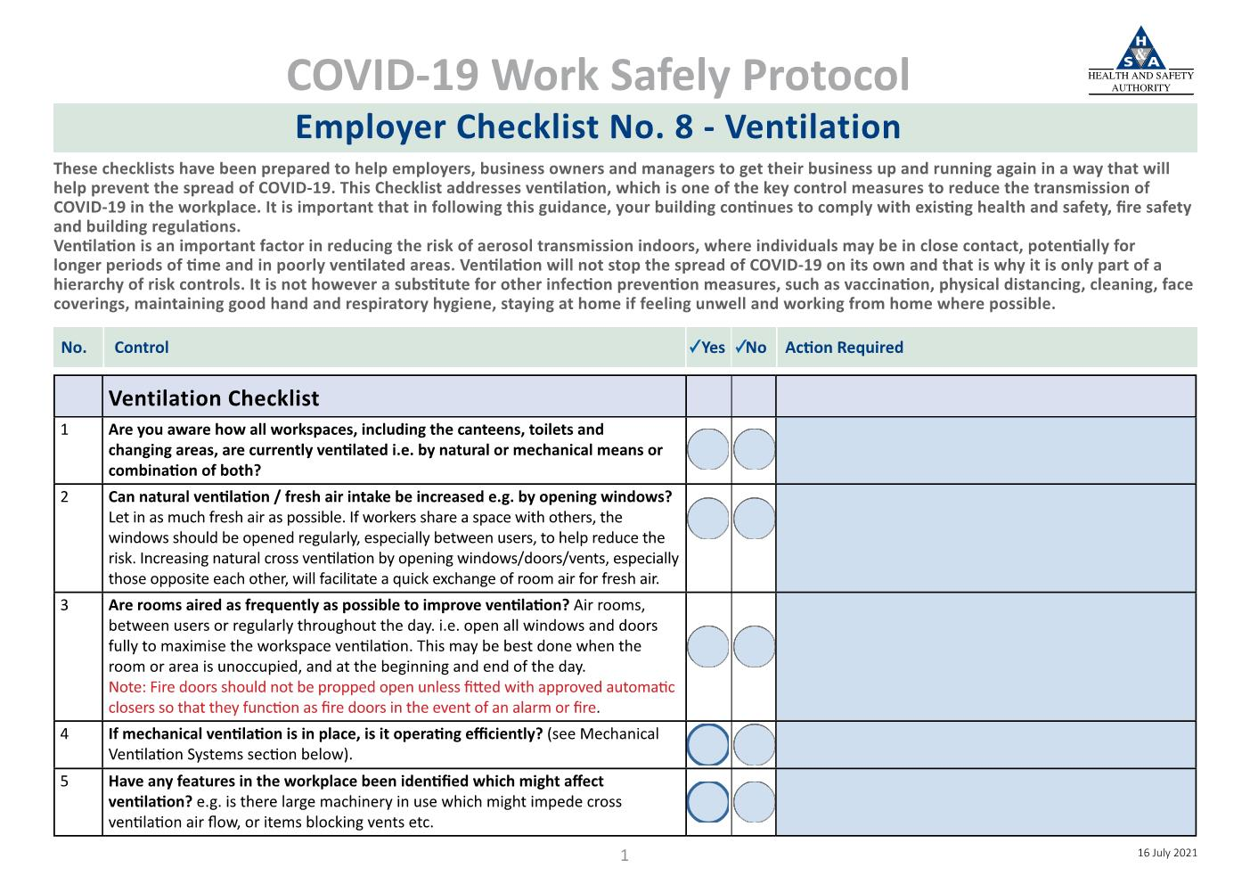
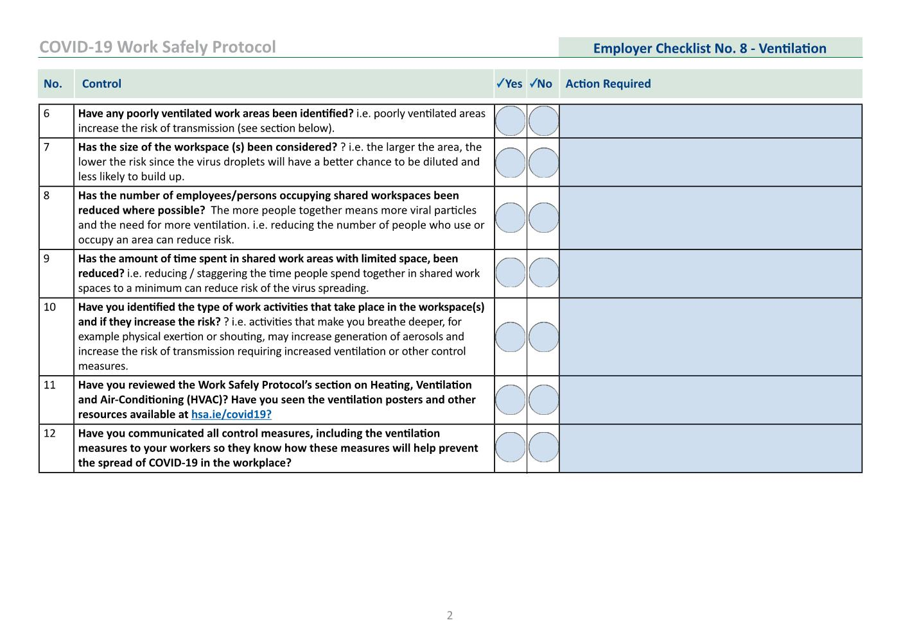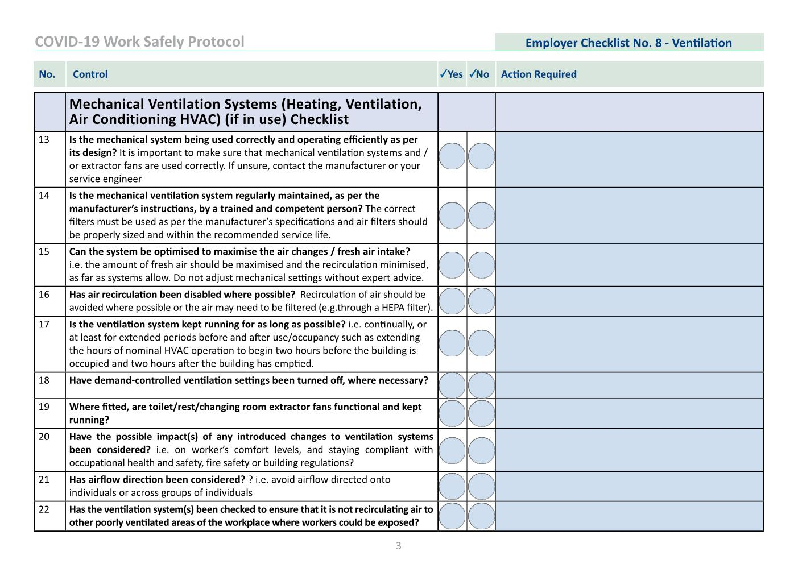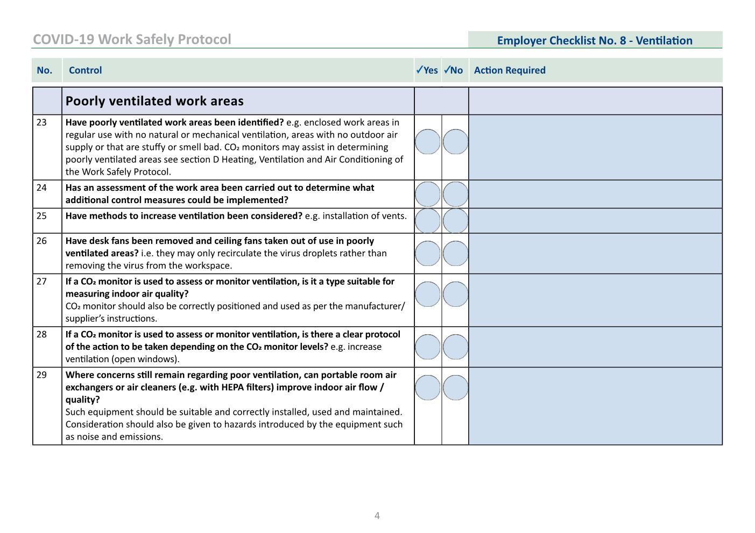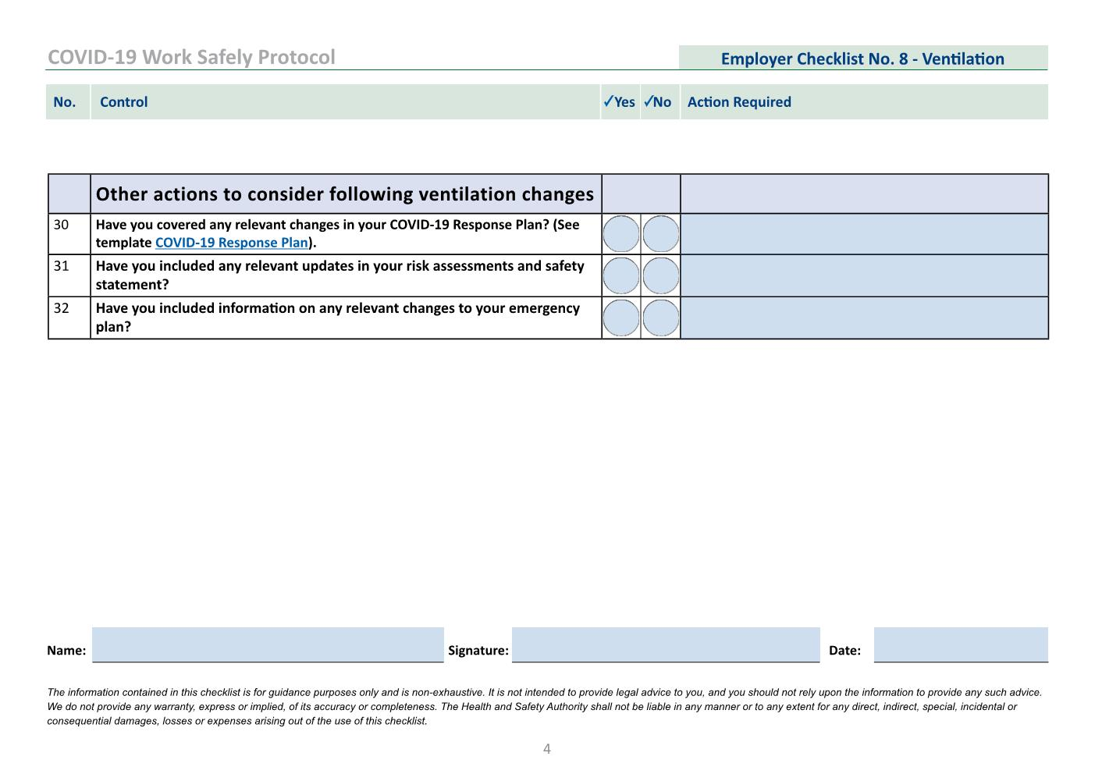

APPENDIX L FOOD AND BEVERAGE

L.1 General Operating Procedures
Food business operators including catering and concessions, must continue to apply their food safety management systems, based on the principles of HACCP. The same food safety requirements apply now as did before COVID-19. Any changes to the nature and extent of the business must be reflected in the food safety management system/HACCP documentation. Food business operators must ensure that all workers have been trained in any new COVID-19 standard operating procedures.

A Health and Safety statement was already required and is still a requirement and must be provided to the organiser for review.

In addition, food and beverage business operators will be required to introduce COVID-19 safety management systems in the form of enhanced hygiene, cleaning and disinfection, worker training and health checks, as well as social distancing. This is to protect against the transmission of the virus to or between workers and patrons.

All food business workers must wear appropriate PPE while serving food, this includes gloves and face masks in line with public health advice.
Hand sanitiser should be placed at all entrances to cold rooms and storerooms. Signage should be put in place to promote hygiene and social distancing. Access systems such as biometric touchpads, keypads or swipe cards must be cleaned and disinfected after each use if in place.
See the below links for further information on food safety.
- Food Safety Authority of Ireland
- Fáilte Ireland

Queuing systems for food business operators, including concessions, should be set up to assist with social distancing while queueing. These may include floor markings, signage and a one-way queuing system. Where barriers are used to define queues, they should not impede emergency escape routes by creating trip hazards or blocking access to exits.
Contactless payments should be encouraged as much as possible.
Queue capacity should be taken into consideration during planning stages. In the case of an outdoor “food court”, consisting of multiple mobile trading units, the queues associated with these maybe longer than usual and may extend into other traders or facilities queuing space or into the pedestrian thoroughfare.
Catering facilities (serving times) for workers may need to be extended to permit staggered mealtimes. Back of house areas require particular attention during large events. Queues and clusters can form quickly where facilities and furniture are being used. Workers can be more relaxed in these environments resulting in breaches in compliance.
Other measures to consider with respect to food and beverage service include:
- Installation of screens between patrons and staff, especially at point of sale;
- Recyclable or biodegradable cutlery and additional bins as required to dispose of them accordingly;
- Removal of condiment stations; and
- Pre-packed condiments and disposable cutlery.

For further guidance on reopening of food and beverage service refer to Fáilte Ireland COVID-19 Support Hub.

L.2 Counter Service
The sale of alcohol at an event should be in-line with guidance at the time of the event, should be subject to risk assessment and must comply with conditions of applicable licensing.
Government Public Health advice is that table service is the safest style of service. Public Health advice is to minimise customer movement and overcrowding within bar counter areas. Some pre-COVID-19 service offerings and queueing systems may have the potential to cause a risk of transmission of COVID-19. In Night club and indoor live entertainment settings patrons may order, pay for and collect drinks from the bar but must leave the bar with drinks, they should be discouraged from congregating at the bar.
The following should be considered in relation to counter service:
- Display signage within the bar service area outlining queueing guidance
- Hand sanitisers should be made available on entry to the premises for customer use and throughout the food counter service area.
- Customers should wear a face covering / mask within the premises
- Employees must wear a face mask
- Poor ventilation in crowded indoor spaces is associated with increased risk of COVID-19 transmission. Ensuring adequate and appropriate ventilation may mitigate some of this risk.

APPENDIX M ACCESSIBILITY
Organisers should ensure that COVID-19 IPCMs do not compromise the rights or quality of the experience for patrons or workers with disabilities. The COVID-19 plan should have regard to the requirements of the Employment Equality Acts 1998–2015 and the Equal Status Acts 2000–2015.
Factors to be considered include:
- Control measures should not prevent a person with a disability from attending or accessing the event;
- The organiser cannot restrict people from attending for reasons of disability. It is for the individual to carry out their own personal risk assessment and determine the appropriateness of their attendance at the event;
- Positions of barriers and infrastructure should not impede the access or circulation route for people with disabilities;
- Social distancing for viewing areas will need to take into account additional distancing required for manual and motorised wheelchairs;
- Positions and legibility of signage should have regard for people with different disabilities;
- Hand sanitisers should be accessible to people with a range of abilities;
- Hand sanitisers, barriers, and other infrastructure should contrast visually with surrounding surfaces, so that they are easily identifiable to people with vision impairment;
- Stewards and COVID-19 compliance officers should be made aware that some disabled people are unable to wear face covering/masks;
- Stewards and COVID-19 compliance officers should be aware that people with hearing impairments may have difficulty understanding them while wearing a face covering/mask and they may need to remove them momentarily, if required, to communicate. They should ensure they maintain social distancing while their face covering/mask is removed and should follow hygiene guidelines when removing their face covering/mask; and
- Isolation rooms/areas should be easily accessible for individuals with varying abilities.

Permanent venues operators should ensure accessibility seating positions are maintained at the same ratio as they exist in the normal venue configuration.

APPENDIX N OTHER SITE ACTIVITIES
There may be other activities and attractions at the event which need to be considered and assessed with respect to the risk of transmission of COVID-19. This may include activities such as -
- Sampling, promotions and marketing activities;
- Meet and greets with artist and performers;
- Interactive games and activities;
- Funfairs and carnival games; and
- Interactive performances and installations.

Event Organisers must ensure activities do not cause an increased risk of infection transmission. These activities should be included or referenced in the COVID-19 risk assessment. Those responsible for delivering these activities shall provide a COVID-19 plan to outline protective measures that will be put in place for the activity.
Sponsorship areas and activations should be restricted to activities where limited contact can be maintained between workers and patrons and where any shared items can be cleaned or replaced between uses.

APPENDIX O FIRST AID AND MEDICAL RESPONSE

O.1 Symptoms of COVID-19
Most people infected with the COVID-19 virus will experience mild to moderate respiratory illness and recover without requiring special treatment. Older people, and those with underlying medical problems like cardiovascular disease, diabetes, chronic respiratory disease, and cancer are more likely to develop serious illness.
The following are the most common symptoms:
- a fever (high temperature of 38ºc or above);
- a cough - this can be any kind of cough, not just dry;
- shortness of breath or breathing difficulties; and
- loss or change to your sense of smell or taste – this means you've noticed you cannot smell or taste anything, or things smell or taste different to normal.

A full list of symptoms can be found on the HSE website.

O.2 Assessing Medical Responses
First aid and medical response required for an event is dependent on a medical risk assessment which takes into account:
- The size of the event;
- The nature of the event and if it takes place in a permanent or temporary venue;
- The location of the event; and
- The demographic of patrons.

For some events and venues, the provision of First Aid Responder(s) (FAR) as part of the event workforce is sufficient, other circumstances may require external Emergency Medical Technicians (EMT) at the event. Larger events including those requiring an event license may require larger numbers of medical teams with onsite ambulances and temporary hospitals.
Regardless of resources in place, first aid and the provision of medical response at events now needs to take into account the risk of transmission of COVID-19 by symptomatic and non-symptomatic patients.

O.3 COVID-19 Responses
Where external medical providers are contracted to provide medical services organisers should ensure that the organisation has updated the event medical plan to include the risk of transmission of COVID-19.
For smaller events/venues who provide first aid only, organisers should ensure those responsible for administering first aid receive necessary training. These individuals may require FAR Responder Recertification.

The individual responsible for first aid and emergency medical response for the event should update the medical plan for the event to address the risk of transmission of COVID-19. They should also:
- Carry out a COVID-19 risk assessment and update documents accordingly;
- Ensure responders have a clear understanding of their additional roles and responsibilities with respect to COVID-19;
- Review all first aid procedures to adapt in line with current COVID-19 guidance. The Pre-Hospital Emergency Care Council (PHECC) has issued an update in regard to COVID-19 and first aid provision in the workplace;
- Ensure sufficient resources are available to deliver first aid including adequate supplies of PPE – single use nitrile gloves, disposable plastic aprons, surgical face masks and eye protection;
- Ensure suitable location for isolation room is identified at Pre-Event meetings and familiarise themselves and responders with these location(s);
- Input into the COVID-19 plan for suspected case of COVID-19; and
- Identify alternative suitable areas for the provision of first aid should the main first aid room become unavailable.

O.4 Administering First Aid
Standard infection control precautions must be applied when treating all patients. Patients should be treated according to Clinical Practice Guidelines (CPG)s, however, when responding to an emergency medical incident;
- Complete a preliminary assessment, if possible, while maintaining social distancing (> 2 metres);
- If the patient requires close contact assessment and/or treatment wear appropriate PPE;
- If the patient demonstrates respiratory symptoms, fever or other cause for concern re COVID-19 apply a surgical facemask to the patient;
- If the patient is unresponsive, check for breathing without using the look, listen and feel (ear to the patient's mouth) process. If aerosol generating procedures are being performed a surgical facemask is not sufficient therefore a properly fitted respirator mask (FFP2 or higher specification) is required;
- Minimise the number of unnecessary bystanders, responders and/or practitioners within the vicinity of the patient, especially in a small room/area or ambulance;
- When patient information is being recorded, request another person, who has maintained social distancing from the patient, to record the details to avoid cross contamination; and
- When the patient encounter is complete, doff and dispose of the PPE appropriately and finally wash your hands.

For more information on administering first aid please see Pre-Hospital Emergency Care Council Website HERE.

0.4.1 Personal Protective Equipment
The below table from extracted from the PHEC website outlines the PPE requirements for transmission routes.
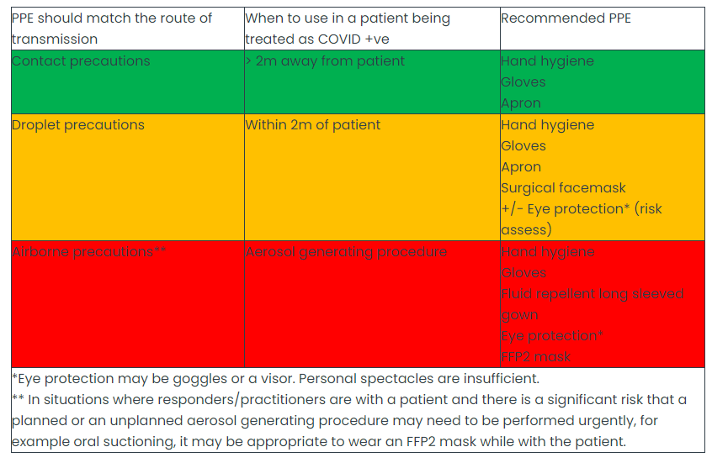
Source PHEC Covid-19 Advisory

APPENDIX P SUSPECTED CASE OF COVID-19 RESPONSE PLAN
Although workers and patrons should not attend the event if displaying symptoms of COVID-19 or if they have had contact with a suspected case, the following outlines the response plan that should be put in place by the Event Organisers/venue managers should someone present with symptoms during the course of the event. Event organisers/venue managers should ensure a coordinated response plan is developed and agreed. Depending on the individual circumstances, suspected case response plan will most likely be coordinated by venue management as they will determine location of the isolation room and provide services such as cleaning and waste management.

P.1 Worker & Performers
If any worker on site (including contractors, suppliers, performers and volunteers) suspects themselves, or are suspected of having symptoms, they must report/be reported to their COVID-19 compliance officer or other designated person.
The designated person must:
- Ensure the person is wearing a face covering/mask or provide them with one if they are not wearing one;
- If a face covering/mask is not immediately available, they should be provided with a disposable tissue and advised to cover their mouth and nose with the tissue when they cough or sneeze and put the tissue in the waste bag provided;
- Accompany the person to the agreed isolation room, keeping a two-metre distance between the person and themselves and other individuals;
- Assess whether the unwell individual can immediately be directed to go home;
- Advise them to contact their doctor;
- Assist the person in arranging transport home or to a hospital for medical assessment. Public transport should not be used;
- Arrange with the appropriate department for cleaning of the isolation room, the person’s work area, and pending a risk assessment, any other areas that the person may have had contact with;
- Log the incident and implement contact tracing; and
- Alert the event controller/ safety officer of the suspected case and the response.

It is important to identify individuals who are considered close contact to assess whether that individual needs to cease working and return home until confirmation of negative or positive test result is received. This assessment should take into account:
- Duration of interaction;
- Location of interaction (whether indoors or outdoors);
- Shared equipment; and
- Vaccination status of the individual.

If there is a confirmed case among workers, the worker involved, their employer and the Event Organiser should cooperate fully with health authority measures. Other workers if identified as a close contact of a confirmed case of COVID-19 should stay at home and not go to work.
Note: Close contacts who are fully vaccinated and do not have symptoms of COVID-19 do not need to restrict their movements or get a test. If fully vaccinated persons develop symptoms of COVID-19 they should self-isolate and get tested for COVID-19.

P.2 Patrons
Ticketholders/patrons should be advised in advance not to attend if they are experiencing any symptoms, are self-isolating, waiting on test results or have been in close contact with someone experiencing symptoms. This should be re-emphasised upon arrival by stewards and signage at key locations.
Should a patron present themselves to a steward or worker, a First aid responder or medical response team should be notified to attend. The patron should then be escorted to the nearest isolation area for assessment.
If assigned seating/standing systems are in place, their seat/area number and contact details should be taken to facilitate contract tracing if requested by the HSE, and to allow for enhanced cleaning of that area. If the symptomatic patron is attending the event in a group, the group members should be treated as close contacts and requested to leave the event also unless fully vaccinated. Note, it may not always be possible to contact or locate remaining pod members or close contacts. The contact tracing log should be completed by the designated person (see below section T.3).
The designated individual will assess if they are safe to travel or should be taken to a hospital. Anyone showing symptoms of COVID-19 should be advised not use public transport and an alternative method of transport should be organised.
Suspected case response plans should be developed in line with event child safeguarding policies.
The Event COVID-19 Compliance Officer, Event Controller and/or Safety Officer should be made aware of and kept up to date with information of any suspected cases of COVID-19.

P.3 COVID-19 Contact Tracing Log for Suspected Case
A COVID-19 log should be completed as part of your COVID-19 response procedure, managed by a designated contact person/case manager. It should be filled in if a person presents themselves as feeling unwell with symptoms of COVID-19. It is not intended to be a substitute for a first aid patient report form.
The aim of the contact tracing log is to effectively identify who has been in close contact and the areas of the venue that may be affected. Inclusions and functions are:
- Workers who have potentially been exposed and what impact it may have on the operations;
- To obtain information for post incident actions required for your place of work to remain functioning; and
- To provide records for the enforcing authorities (HSE, HSA) should they require further information.

P.4 Isolation Room
Isolation room(s) should be provided and used to isolate a person who is experiencing COVID-19 symptoms. This is to facilitate the person remaining in isolation prior to going home, or to facilitate the attendance of a doctor.
The isolation room should be a separate area to the first aid room. However, the first aid room may need to become an isolation area if a patient receiving first aid treatment shows symptoms of COVID-19 while being examined by the first aider.
Multiple isolation rooms may be required depending on the size and orientation of the event. The route(s) to the isolation room(s) need to be quick and easily accessible with as little human interaction as possible. Isolation rooms should be universally accessible.
Each isolation room should have the following in place:
- Ventilation, e.g. fresh air / openable windows;
- Tissues;
- Hand sanitiser;
- Disinfectant and/or wipes;
- PPE: Gloves and surgical masks ;
- Waste bags; and
- Pedal operated closed bin.

Isolation Rooms must be fully sanitised and disinfected following the use by a suspected case.

P.5 Cleaning Guidelines after the Presence of a Suspected Case of COVID-19
Once a person with suspected COVID-19 is identified in a setting, all surfaces that the person has been in contact with (not the entire building) should be cleaned and disinfected, before use by others.
- Public areas where a person who had symptoms of COVID-19 has passed through and spent minimal time, such as corridors, but which are not visibly contaminated with body fluids, can be cleaned as normal;
- Once the room or affected area is vacated, it should not be reused until the room has been thoroughly cleaned and disinfected and all surfaces are dry;
- Wait a minimum of one hour, or longer if possible, before going in to clean a room. The amount of live virus decreases over time on surfaces thereby lessening the risk of contamination from touching a surface that had the virus on it. Open the window in the room while cleaning is in progress;
- Workers responsible for cleaning after a suspected or confirmed COVID-19 person was present should wear disposable single use non-sterile nitrile gloves and a disposable plastic apron and should avoid touching their face during the cleaning procedure. If an area has been heavily contaminated, such as with visible bodily fluids, from a person with COVID-19, use protection for the eyes, mouth and nose, as well as wearing gloves and an apron. Avoid creating splashes and spray when cleaning;
- Once the room has been cleaned and disinfected and all surfaces are dry, the room or affected area can be put back into use;
- Clean the environment and the furniture using dampened cleaning cloths and a household detergent followed by disinfection with a household bleach;
- Shared equipment that had been used by an individual who was positive with COVID-19, should be disinfected before use by another person e.g. phones, keyboards, pens, handles, seats;
- Pay special attention to frequently touched flat surfaces, the backs of chairs, door handles and any surfaces or items that are visibly soiled; and
- Carpets do not require special cleaning unless there has been a spillage.

Cleaning guidance used in non-healthcare settings: general cleaning principles, and cleaning guidance when a person with COVID-19 has been in the setting are HERE.
Waste: if a person is diagnosed with COVID-19:
- All personal waste including used tissues and all cleaning waste should be placed in a plastic rubbish bag;
- The bag should be tied when it is 2/3rd’s full (so it doesn’t spill over) and then placed into a second bin bag and tied; and
- Once the bag has been tied securely it should be left somewhere safe. The bags should be left for three days before collection by the waste company.

P.6 Reporting and Investigation

Single Cases
COVID-19 is reportable under the Infectious Diseases (Amendment) Regulations 2020 by a medical practitioner who becomes aware of or suspects an instance of such disease. There is a requirement for an employer to notify the HSA if a worker contracts COVID-19 under the Biological Agents Regulations (S.I. No. 572 of 2013) where a risk of occupational exposure to COVID-19 is identified, as a result of working with the SARS-CoV-2 virus. For example, employees working directly with infected patients/ service users, laboratories and testing facilities handling the virus and waste companies handling SARs-CoV-2 contaminated waste etc.
There is currently no required for employers to report cases to general work environments.

Outbreak
An outbreak of COVID-19 is when two or more cases of the disease are linked by time, place or person. The management of an outbreak is managed by the local Departments of Public Health to enable the outbreak to be brought under control as quickly as possible. Further it requires close engagement and cooperation between the Event Organisers, the employer, the LWR, the workers and in particular with the individual(s) affected. Outbreaks in a single workplace or as a result of an event, which are not managed and brought under control quickly, can rapidly spread to other workplaces and/or the wider community. Continuous and effective communication between all parties is essential.
Additional advice on dealing with a suspected case or managing an outbreak are available from the HSPC Guidance of Work Place Outbreaks.

P.7 Returning to Work after Suspected Case
Organiser should develop a procedure for workers returning to work after an absence due to COVID-19. The HSA provide resources for employers and employees HERE.

APPENDIX Q MONITORING, REVIEW AND OVERSIGHT
Monitoring, review and oversight for the event can be broken down into three distinct phases: before, during and after the event has taken place.

Before
The COVID-19 plan should be reviewed regularly and updated as new regulations, guidelines and best practice become available. This may happen throughout the planning stages right up to your event date. Therefore, it is important to have appropriate contingency plans in place for unexpected changes.
The Event Organiser should ensure an inspection of the event site is carried out before opening to the public to confirm that all control measures and resources are in place. A sample control measure checklist can be found at on the Health and Safety Authority website, though it is recommended that a venue/event specific checklist be developed for each event.

During
All control measures implemented must be monitored on a continuing basis. The COVID-19 compliance team and COVID- 19 Compliance Officers are responsible for monitoring compliance before during and after the event. They should work in conjunction with all workers to ensure strict compliance on event days. They should also perform the following duties, this is a non-exhaustive list:
- Ensure cleaning and disinfection has been carried out to all areas;
- Ensure the event has appropriate infrastructure is in place, such as has Perspex screens, sanitation stations, barriers for queue management, signage, etc.;
- Monitor workers for compliance with IPCMs and take appropriate action where required;
- Monitor patrons for compliance with IPCMs and take appropriate action where required;
- Ensure seats not in use are appropriately and safely blocked off; and
- Ensure toilet facilities have appropriate social distancing and hygiene measures in place.

After
Experience and feedback will inform how appropriate and effective the COVID-19 plan is. A post-event review should take place following each event to discuss any issues which may have arisen and develop systems on how to improve on them ahead of the next event. Outcomes should be shared openly with all stakeholders so that lessons learned can be passed between other venues, events, organisers, statutory bodies and local authorities.

Inspection
Venues maybe subject to inspection by Compliance Officer from the Health Service Executive and/or the Health and Safety Authority to confirm compliance with appropriate COVID-19 regulations. All documentation and records should be made available to the compliance officer on request. Failure to do so could result in closure and/or prosecution under the act.

APPENDIX R ALCOHOL BASED HANDS RUBS SAFE USE
Installation of these dispensers within both rooms and outside rooms within corridors should have the following considerations:
- Individual alcohol-based hand sanitizing dispensers do not exceed a maximum individual capacity of 1.2 litres;
- Dispensers are not installed above electrical outlets, light switches or other heat or potential ignition sources. They should be 1.2 metres or more away from same or as far as is possible and the risk assessed.
- They shall be affixed to a non-combustible wall surface such as plasterboard, block or concrete;
- No bins, presses or other such items to be located proximal to hand sanitiser dispenser;
- The activation button to release hand sanitizer should be located 1.2 metres above floor level to allow persons in wheelchair to access it;
- Dispensers are to be located in well-ventilated areas with no open drains or access points to waste/drainage;
- A drip tray to be located under dispensing point and any waste to be disposed of safely and regularly into a fire-resistant waste container;
- Corridors where dispensers are installed have a minimum width of 2 metres and may not be provided with a combustible floor covering such as carpet. (Note:-The sanitizer may damage floor surface in particular historic floor surfaces);
- Dispensers that project more than 90mm into a corridor are clearly noted in the facility’s Health and Safety Plan;
- Additional fire extinguishers to be located near dispensing point. Extinguishers should be Dry Powder of Wet Chemical Type. (Note: Water and AFFF Foam Extinguishers are ineffective on chemical-based fires (Class C));
- All storage of replacement alcohol-based hand sanitizing containers on floors, should be limited in quantity to the weeks requirements and shall be within approved flammable liquid storage cabinets;
- Bulk storage of these gels should be in a properly ventilated and fire-resistant room located remote from the main building and away from escape route; smoke detectors should be provided and linked to the main alarm in this room. (Bulk storage is considered to be any storage over 50L);
- Do not transfer the gels/liquids to the dispensers within the bulk storage room; this should ideally be done externally or in a well-ventilated hazard free room and clean up any spills immediately. Dispose of spills/clean up materials in flammable waste/hazardous waste;
- All Staff should be made aware that there is a very small risk of high alcohol content hand gels being ignited due to a build-up of static electricity. While these events are extremely rare, staff should allow time sanitizers to be completely absorbed into the skin prior to commencing any work activity;
- All staff should be made aware, that there exists the possibility that static electricity (generated from various sources including clothing) can ignite the alcohol in the gel and that they must wait/be careful rubbing hands together or they can touch hand to metal prior to putting gel on hands; and
- A risk assessment and review of training and fire safety measures to be undertaken prior to installation of these dispensing unit, with specific reference to these units and the hazard of fire.

